**Mo Scalextric Team 1**

**Technical Report**

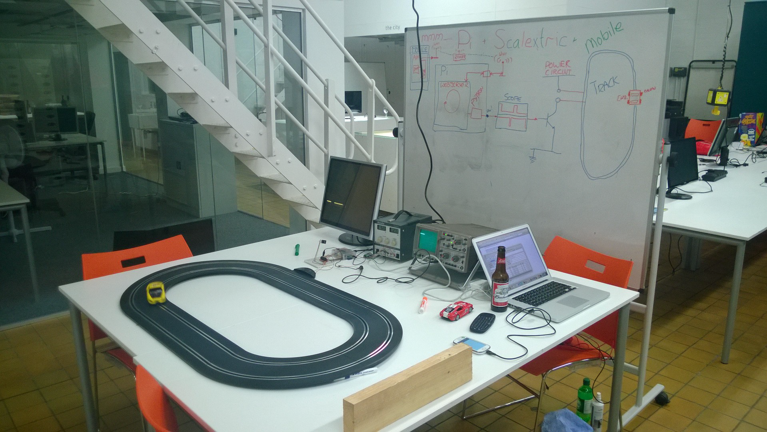

[**https://moodle.mmu.ac.uk/mod/forum/discuss.php?d=458738**](https://moodle.mmu.ac.uk/mod/forum/discuss.php?d=458738)

## 

## Scalextric Team 1

Project manager - Hamza

Tech lead - Aubrey

Client advocate - Munashe

User advocate - Akbar

# 

# Contents Page

Scalextric Team 1 1

**Contents Page** **2**

**Introduction** **5**

**Discussions** **6**

**Requirements** **7**

InScope-core: 7

On-boarding: Player ID: 7

On-boarding: Single Player: 7

On-boarding: Two Players: 7

Casual: 7

Laps: 7

Lap Times: 7

Controls: General: 8

Quit: General: 8

Weapons: General: 8

Weapons: Stinger: 9

Weapons: Oil Slick: 9

Weapons: Smart Bomb: 9

Weapons: Reverse Control: 9

Weapons: Rickroll: 9

InScope-sacrificial: 9

Race: Challenge: 9

Race: General: 9

Race: Prolog: 10

Race: Start: 10

Race: Complete: 10

Quit: Race: 10

OutOfScope: 10

On-boarding: Queue: 10

On-boarding: Quit The Queue: 10

Players Waiting Nag: 11

**Investigations** **11**

‘How do I use the browser debugging tools?’: 11

‘Scalextric: What is NodeRED?’: 11

‘Scalextric: What is the Publish and Subscribe Concept’: 11

‘Scalextric: What is MQTT?’: 12

‘Scalextric: What is AngularJS?’: 12

‘What is GitHub Pages?’: 12

‘What is Evolus Pencil?’: 12

**User Stories** **13**

Stakeholders 13

Alice - Casual User 13

Frank - Casual User 13

Casual Alone 14

Alice is first to join 14

Alice switches throttle position 14

Alice quits 14

Casual Interactive 14

Frank is second to join 14

Frank challenges Alice to a race 14

Race 15

Alice and Frank race 15

Alice wins the race 15

Frank quits the race 15

Weapons 15

Usage 15

Stinger/Puncture 15

Oil Slick 16

Smart Bomb 16

Rick Roll 16

Reverse Control 16

**Features Board** **17**

Web Application 17

State Diagram 17

Homepage 17

Casual Alone 20

Casual Interactive 20

Challenge 23

Pre Race 25

Race 25

Weapons 28

Definitions 28

**Wireframes** **32**

Homepage 32

Casual Alone 32

Casual Interactive 33

Race 33

Make Challenge 34

Accept Challenge 34

Pre Race 34

Won Race 35

Lost Race 36

**Design** **36**

Web Application 36

**Implementation** **44**

**User guide** **48**

**Handover report** **49**

Features 50

**Conclusion** **52**

# 

# Introduction

Welcome to Mo’ Scalextric Team 1. This Live Project hosted by Digital Labs involves making a Single Page Web Application (SPWA) that controls a scalextric track which is hooked up to a Raspberry Pi. Our aim is to create a racing game that allows people to race against each other on a scalextric track using their smartphone. We need to make our app easy to use and want to include features such as different weapons that players can use against each other and also a competitive race mode.

Our plan is to use Trello (web-based Kanban-style list-making application) alongside a Scrum for Trello plugin to organise our thoughts and aid the development process. With Trello we can list our requirements, carry out investigations and discussions to create our design. Gantt charts in Trello were used to record our progress to show who is doing their tasks. Therefore, we can use trello as our source to navigate our way to progressing through the project.

Project Manager and Tech Lead were in charge of discussing tasks that needed to be completed and then allocated to various members of the group for each sprint. Also using the Scrum plugin we were able to allocate an estimated time and the fill in the time took for completion.

Our GitHub for the SPWA can be found here:

<https://github.com/liveprojects-julien/pi_scalextric_t1_spwa>

# Discussions

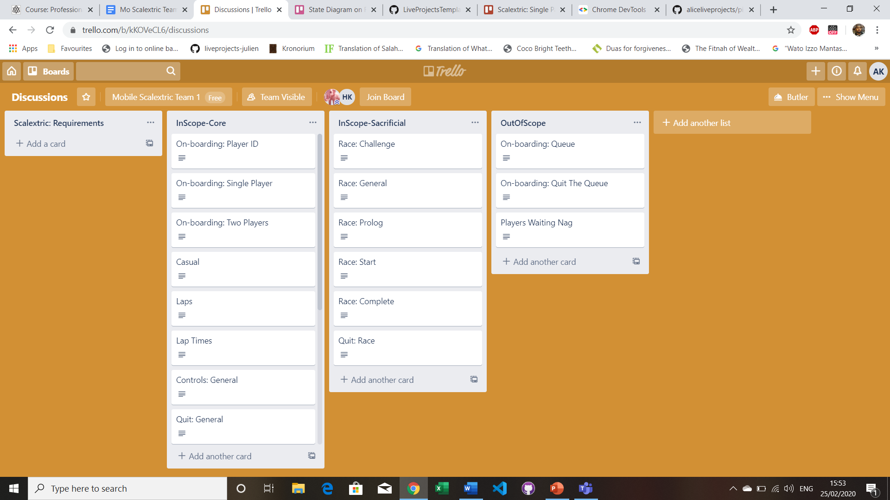

Fig 1.0

This is the portion of our Trello where we have been discussing our different requirements and how they will work. Trello board shown in Fig 1.0.

The InScope Core would include player onboarding, general controls and weapons. These would be our main objectives to focus upon, this is due to our predictions of our time remaining and the commitments we can make.

The InScope-Sacrificial cards became things which we could either look back on if we are efficient with the core features to add these further implementations. We could also abandon these ideas since these are not our main goals but to be considered as extra features to implement.

And finally the OutOfScope is our list to add cards that we would not consider to work on as our time and efforts are limited to only a certain amount of cards that we have in the core and sacrificial cards.

This is all evaluated in more detail below in our Requirements section.

# Requirements

Our requirements outline and explain what the main features of our application are. We started off with one list of requirements and organised them into one of three categories: InScope-core, InScope-sacrificial and OutOfScope. These categories decided what our aims were and what we had to abandon in order to get as much as we can done. See below for details from our discussion board.

## InScope-core:

### On-boarding: Player ID:

When a player wants to join the game, they will be asked for some form of identifier, which can be recognised and repeated by them.

ideas:

3 letters (classic)

8x8 (github style)

fruit selection (choice of fruit / food pairing: jemon jelly; durian waffle)

### On-boarding: Single Player:

Alice arrives at the venue. She has a mobile phone. We want her to be able to play Scalextric by herself until someone else joins her.

### On-boarding: Two Players:

Alice and Bob are at the venue, they have mobile phones. We want Bob and Alice to be able toPlay Scalextric casually, but to be able to have a proper race, if they want to.

### Casual:

Once on-board, a user can play casually for as long as they wish to.

### Laps:

A count of the number of laps a user has run is kept.

### Lap Times:

Each user's lap times are logged

### Controls: General:

The user has the following controls at their selection:

1. Throttle

2. Weapon selector

3. Counter measures selector

3. Trigger

Arm a weapon by tapping it. Disarm it by tapping again.

Arm a counter measure by tapping it. Disarm it by tapping again.

Weapons must be disarmed before countermeasures can be deployed.

Counter measures must be disarmed before weapons can be deployed.

Trigger is pressed to deploy the selected weapon or counter measure.

### Quit: General:

Users can quit at any time

### Weapons: General:

Weapons can be used at any time.

All weapons may be used, and then there is a recovery time.

The recovery time depends on the weapon.

This is so that weapons can only be used in challenge mode.

Weapons can be fired at any point. Some weapons may require support from the Pi, if they affect the cars.

### Weapons: Stinger:

When the Stinger is activated the targeted car cannot move for a couple of seconds

### Weapons: Oil Slick:

When the Oil slick is activated the targeted car is uncontrollable for 10s.

### Weapons: Smart Bomb:

When the Smart Bomb is activated the targeted car comes off the track.

### Weapons: Reverse Control:

When the Reverse Control is activated the targeted car the controls for the player get reversed.

### Weapons: Rickroll:

The weapon hits the user and now their screen is blocked by a video/image of Rick Astley for 20 seconds.

## InScope-sacrificial:

### Race: Challenge:

When playing casually, any user may issue a challenge.

The challenge is available for the other track users to accept.

Only one challenge can be active at any one time.

Once all track users have accepted the challenge a race can start.

### Race: General:

A user is able to race against the other users.

The race is over a certain number of laps, (20?)

At the end of the race, there is a winner.

They may see their race statistics.

At the end of the race, both racers lose their ownership of the track.

They may on-board again.

### Race: Prolog:

When a race challenge has been accepted, an all on the track are ready to race, the car moves to the start position and stops.

The start position is indicated by the trackside car-sensors.

### Race: Start:

Once at the start position, the race countdown begins for all users.

In the traditional way, this is 3 beeps and 3 lights: red, red, green.

Once the race starts, the users are free to control their cars, as for casual racing, except the race lap counter for each car is incremented to the race lap count.

### Race: Complete:

When a race is complete, the winner, and the race statistics are displayed.

### Quit: Race:

A user can quit a race. When they do, the race continues until the other player completes, or quits.

## OutOfScope:

### On-boarding: Queue:

We want any potential player to be able to scan the QR code, and be asked to wait in a queue until a track is free.

We want the SPWA to automatically notify a player when a track is free.

We want the system to recognise if a player no longer wants to wait in the queue, and to skip to the next waiting player.

### On-boarding: Quit The Queue:

We want any members of the queue to be able to quit at any time

### Players Waiting Nag:

When playing casually, a user is informed the moment that a person enters the queue and is unable to race.

At a subsequent time interval (2 minutes?) the user is nagged with the number of people in the queue.

Nagging stops when the user enters a race.

# 

# 

# Investigations

In our investigations we were required to understand the fundamentals of what was needed to progress with our implementations. Each member of the group was required to research each of these topics so that they were able to gain a full understanding of the different technologies involved.

These are the different Investigations we carried out:

## ‘How do I use the browser debugging tools?’:

This was a fairly straightforward investigation as Chrome already provide a full tutorial on the browser debugging tools, this can be found here: <https://developers.google.com/web/tools/chrome-devtools>

Our first step was to follow the tutorials provided by chrome. Next we took the source code already provided to us from Digital Labs and evaluated it using the debugging tools, we did things such as step through the source code and also look at the various network requests as we operated the app.

## ‘Scalextric: What is NodeRED?’:

This investigation required a small amount of research, we also already had NodeRED on our Pi meaning we could look at how it worked with a more hands on approach.

NodeRED is an open-source visual editor, it is used to ‘wire’’ together hardware devices, APIs and online services.

## ‘Scalextric: What is the Publish and Subscribe Concept’:

Again this just required a little bit of online research, here is what we found:

Publish/Subscribe is a style of messaging application which the providers of information(publishers) to have no direct link to a specific consumer of the information(subscribers). The interactions between the publishers and subscribers are controlled by brokers. The publisher does not need to know who uses the information (publication) that it provides, and the subscriber does not need to know who uses the information that is the result of a subscription. Information is sent from the publisher broker.

## ‘Scalextric: What is MQTT?’:

MQTT stands for MQ Telemetry Transport and is a publish and subscribe network protocol. The broker receives messages from the client/publisher, then filters the messages and finally publishes the messages to all the clients. The publish / subscribe concept works like this: a device/client publishes messages that other devices can subscribe to or devices/clients can subscribe to topics they only receive. Shown in Fig 2.0 below.

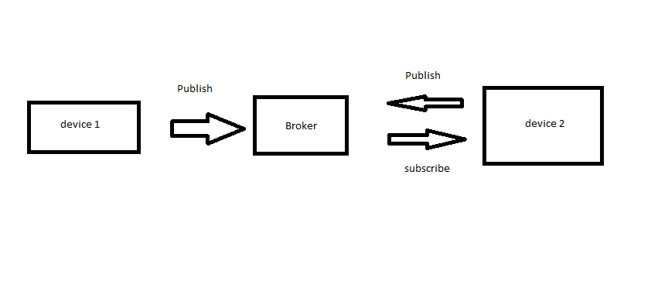

Fig 2.0

## ‘Scalextric: What is AngularJS?’:

This was the main majority of our investigations since our entire app was built using this framework.

It is a javascript front end web framework that is very useful for single page web apps.

Helpful tutorials: <https://ui-router.github.io/ng1/tutorial/helloworld>.

Documentation: <https://code.angularjs.org/1.7.2/docs/api>.

The main first and most important Angular investigation was to create a simple app that allowed you to switch between 2 states, next up was Figuring out how exactly could we connect our SPWA to our MQTT broker and finally we had to work out how the weapons that were already on the system were used by the app.

## ‘What is GitHub Pages?’:

A hosting service for HTML, CSS and JS used for github. This is where we will be hosting our SPWA.

## ‘What is Evolus Pencil?’:

Evolus pencil is a drawing tool where we will be able to create a template of our SPWA.

# User Stories

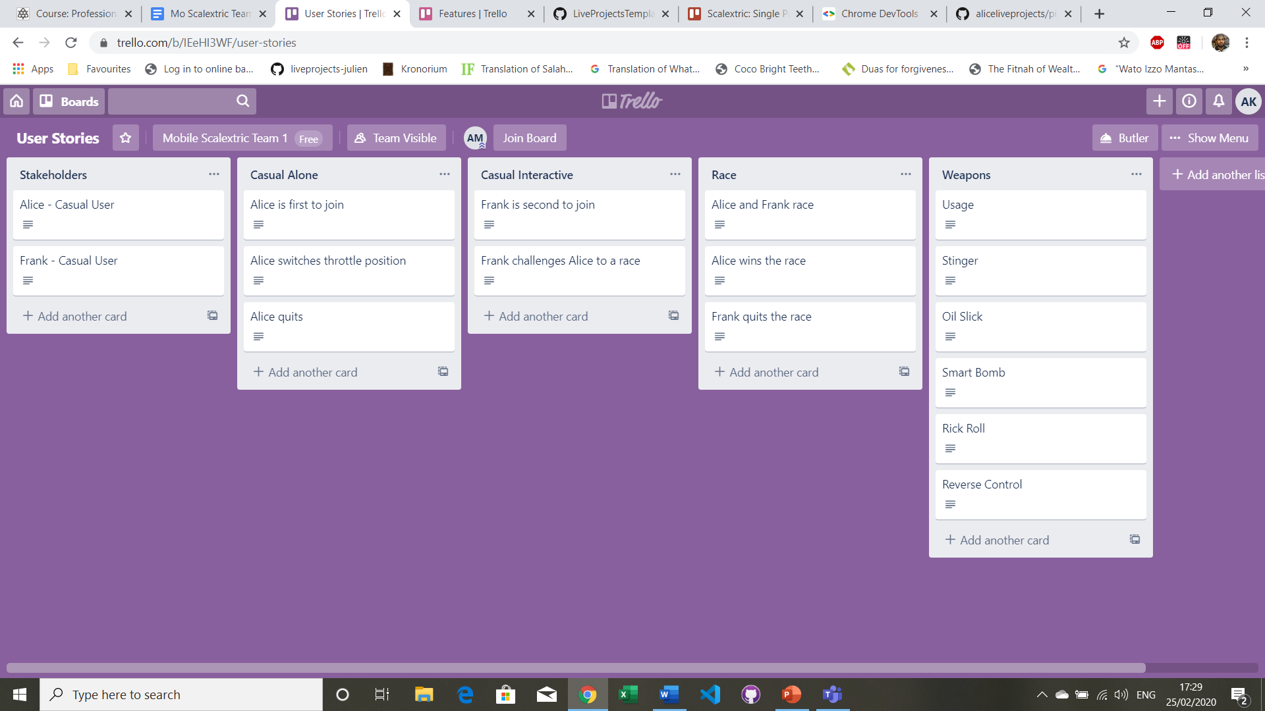

Fig 3.0

In the user stories, there are five categories which we decided upon. Each user story card has a description outlining what the user does. Trello board shown in Fig 3.0 above. Here are all the User Stories we wrote:

## Stakeholders

### Alice - Casual User

Alice uses her smartphone to scan the QR code and then downloads the SPWA, this brings her to the Join Track Page.

### Frank - Casual User

Frank uses his smartphone to scan the QR code and then downloads the SPWA, this brings him to the Join Track Page.

## Casual Alone

### Alice is first to join

There is nobody on the track.

Alice is at the Join Track page.

Alice enters her name.

Alice chooses a track.

Alice clicks the GO button.

Alice enters Casual Alone mode.

Alice sees that she is the only one on the track.

Alice can now control her car using the throttle on her phone.

Alice wants to use special weapons but she can't as she's the only one on the track.

Each time Alice completes a lap her time is added to the laps list.

### Alice switches throttle position

Alice clicks on the throttle switch.

The throttle moves to the opposite side of Alice's Screen.

### Alice quits

Alice clicks the quit button.

She is brought back to the Join Track page.

## Casual Interactive

### Frank is second to join

Alice is already on the track.

Frank is on the Join Track page.

Frank enters his name.

Frank chooses a track.

Frank clicks the GO button.

Frank and Alice enter Casual Interactive mode.

Frank can see his and Alice's name on the players list.

Frank can now control his car with the throttle and sees that special weapons are enabled.

Alice can now also use special weapons.

Each time either player completes a lap the time is added to the laps liist.

### Frank challenges Alice to a race

Frank clicks Alice's name on the players list.

Frank is asked to confirm if he wants to challenge Alice.

Frank click YES.

Alice's receives a challenge request.

Alice accepts Frank's challenge.

Both players are told to move their cars to the start line and click done when ready.

Both players move their cars to the start line and click done.

Both players enter Race mode.

## Race

### Alice and Frank race

Frank and Alice are able to race their cars against each other by using the throttle to control them.

Each time either Frank or Alice completes a lap the time is recorded at the side of the screen.

Once a player completes 3 laps before the other they are declared as the winner of the race.

### Alice wins the race

Alice is the first to complete 3 laps.

Alice is declared the winner of the race.

Both players return back to Casual Interactive mode.

### Frank quits the race

Frank is racing against Alice.

Frank selects the Quit button.

Frank is declared the loser of the race.

Both players are taken back to Casual Interactive mode.

## Weapons

### Usage

Weapons are able to be used when there are 2 players on the track either in Casual Interactive mode or Race mode.

### Stinger/Puncture

Frank selects the stinger weapon from the weapons menu, the stinger is now activated.

Frank fires the weapon.

The weapon hits Alice and now she is not able to move her car for 10 seconds.

### Oil Slick

Frank selects the Oil Slick weapon from the weapons menu, the Oil Slick is now activated.

Frank fires the weapon.

The weapon hits Alice and now she is not able to use the throttle and the throttle speed of her car is oscillated between 0 and 100 so her car wobbles around the track, this last 10 seconds and then Alice regains control.

### Smart Bomb

Frank selects the Smart Bomb weapon from the weapons menu, the Smart Bomb is now activated.

Frank fires the weapon.

The weapon hits Alice and now her throttle is momentarily set to 100 and her car comes off the track.

### Rick Roll

Frank selects the Rick Roll weapon from the weapons menu, the Rick Roll is now activated.

Frank fires the weapon.

The weapon hits Alice and now her screen is blocked by a video/image of Rick Astley for 10 seconds. https://www.youtube.com/watch?v=dQw4w9WgXcQ

### Reverse Control

Frank selects the Reverse Control weapon from the weapons menu, the Reverse Control is now activated.

Frank fires the weapon.

The weapon hits Alice and now her throttle speed is reversed for 10 seconds.

#### 

# 

# 

# 

# Features Board

Our features board explains all our intended features of our app in more detail and also provides a visual representation of our UI.

Here is a list of all our features and states, along with their explanations

## Web Application

### State Diagram

The state diagram is a vital part of our design, it conveys each state that a user of our application will go through while using our app.

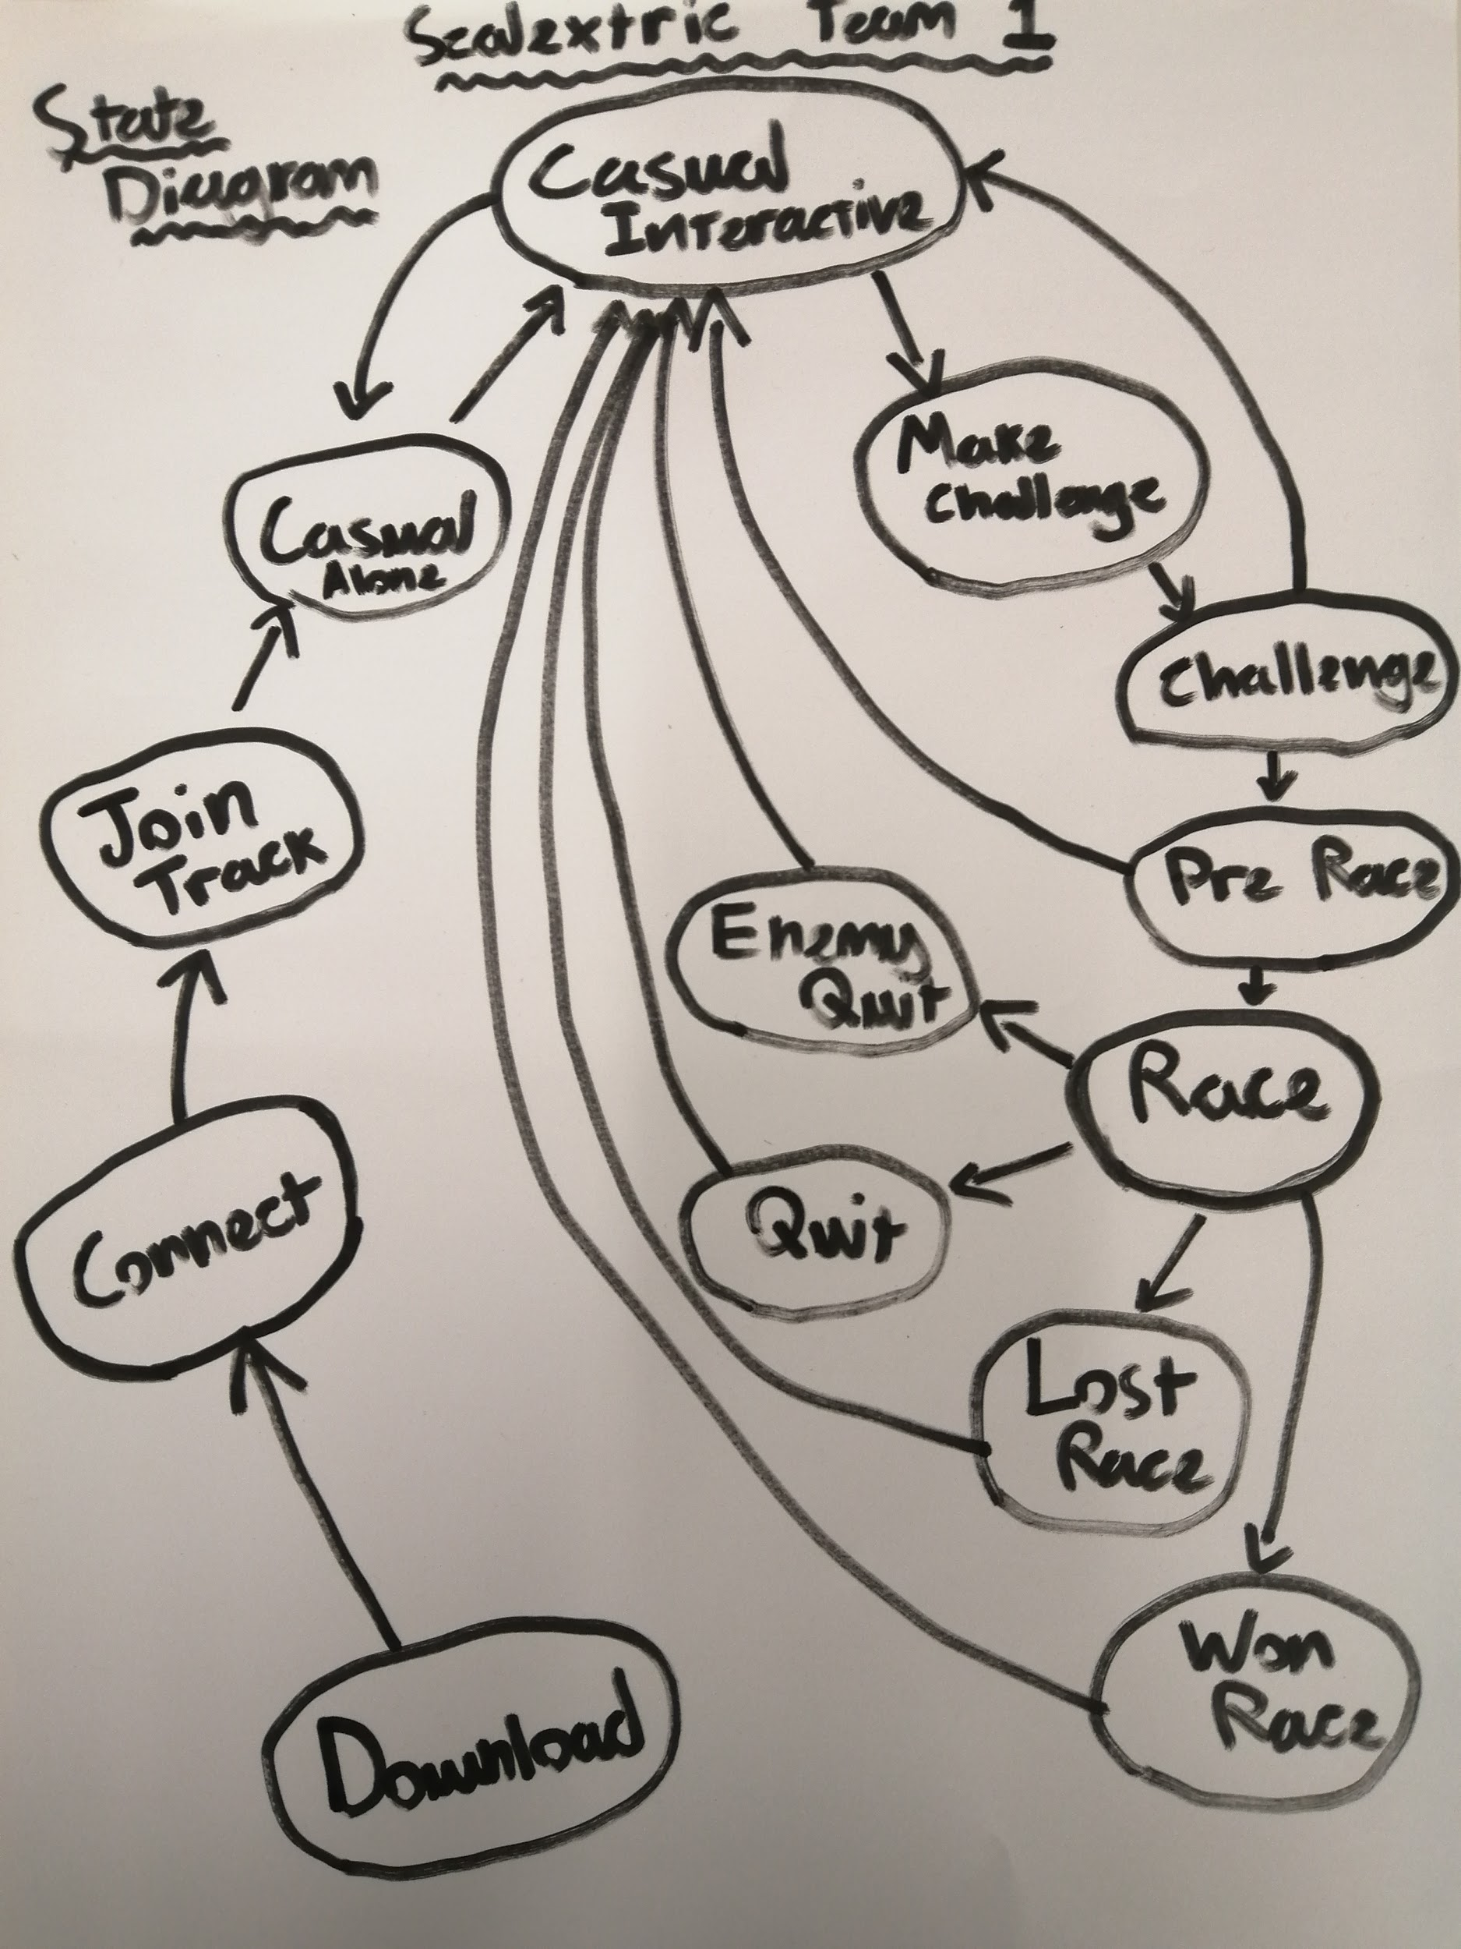Fig 4.0

### Homepage

The Homepage is the first thing the user will see after scanning the QR code and downloading the SPWA, on the home page the user will be able to enter their name and select a track (Channel) and then click the Join button to enter Casual Mode.

UI:

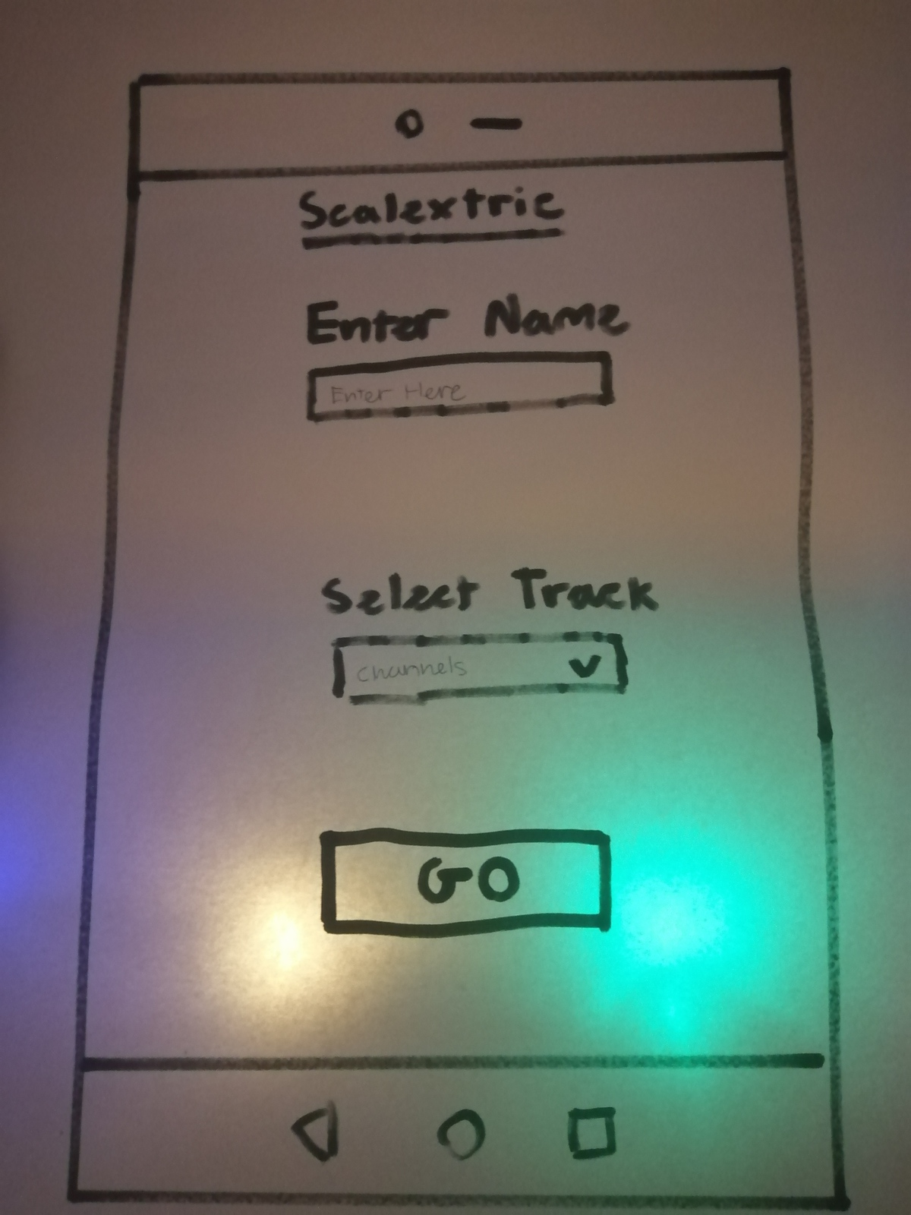

Fig 4.1

Enter name:

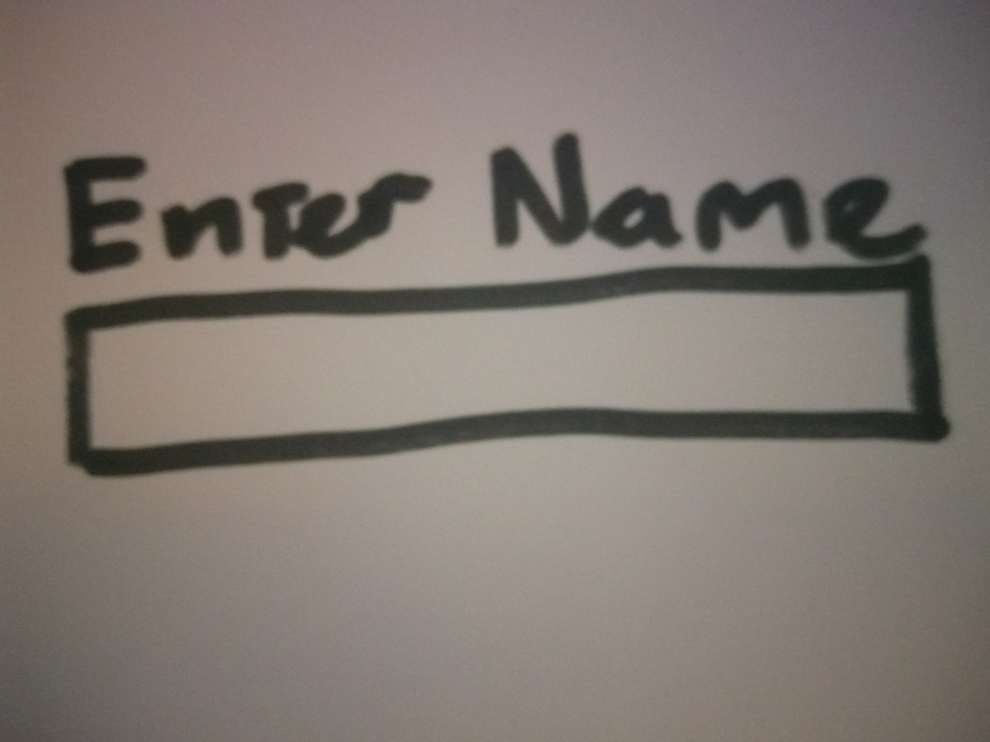Fig 4.2

Select Track:

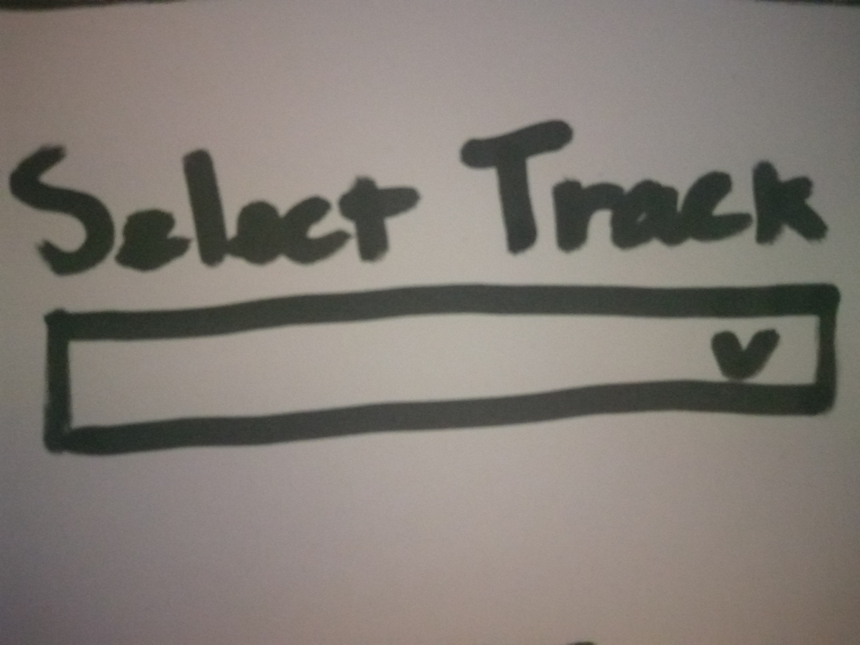Fig 4.3

Join Button:

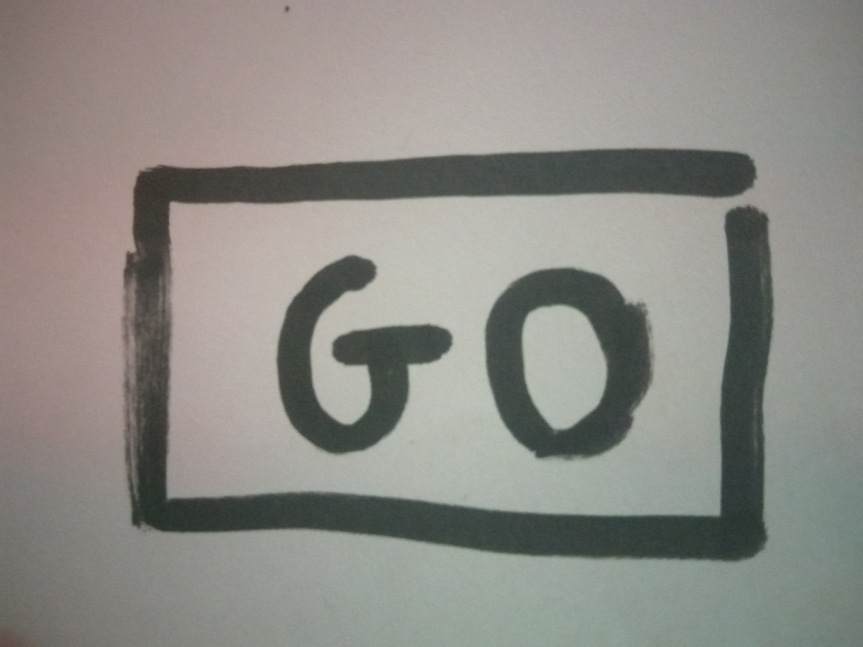Fig 4.4

### Casual Alone

When the user has joined the track but there are no other users this is the mode that they will enter. (Weapons are disabled in this mode but UI is the same as Casual Interactive)

### Casual Interactive

When the user has joined the track and there is another user this is the mode that they will enter.

UI:

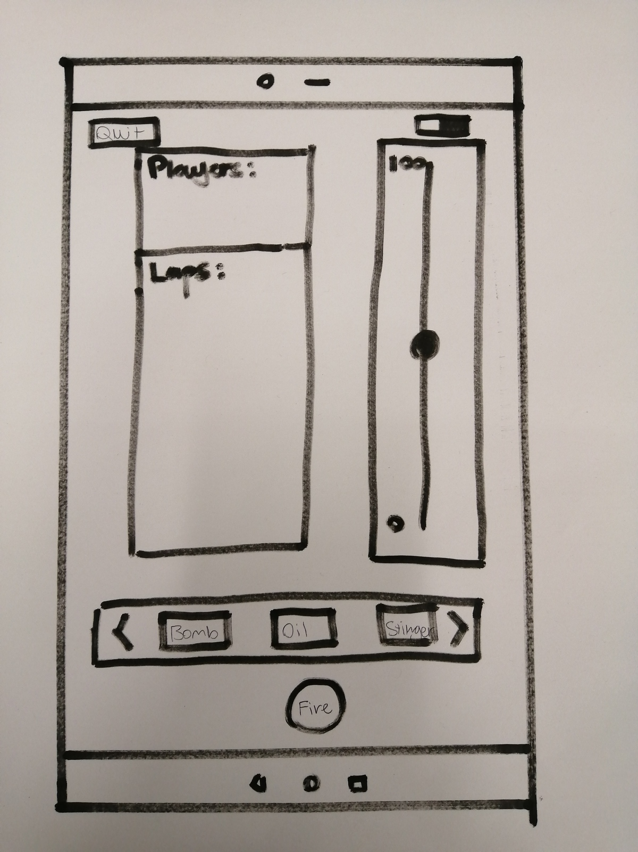Fig 4.5

Quit Button:

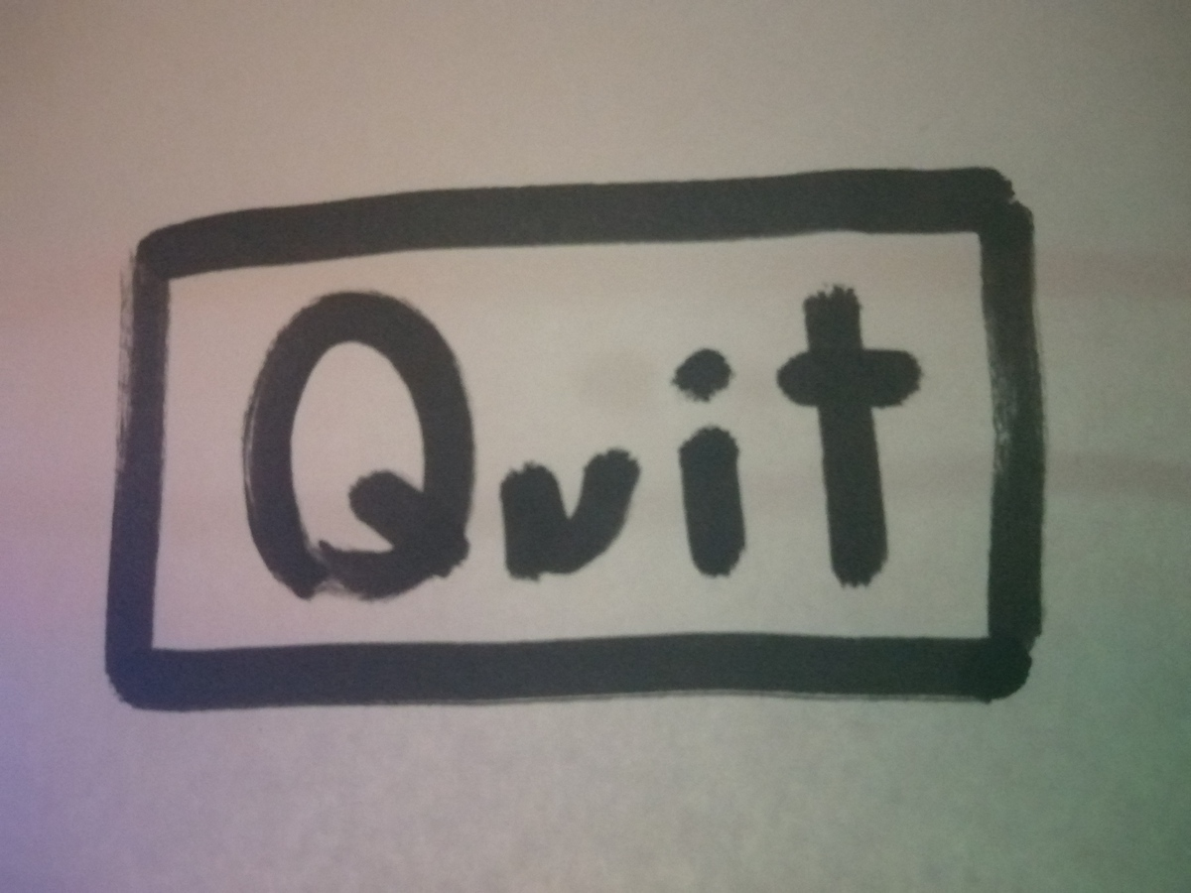Fig 4.6

Player List:

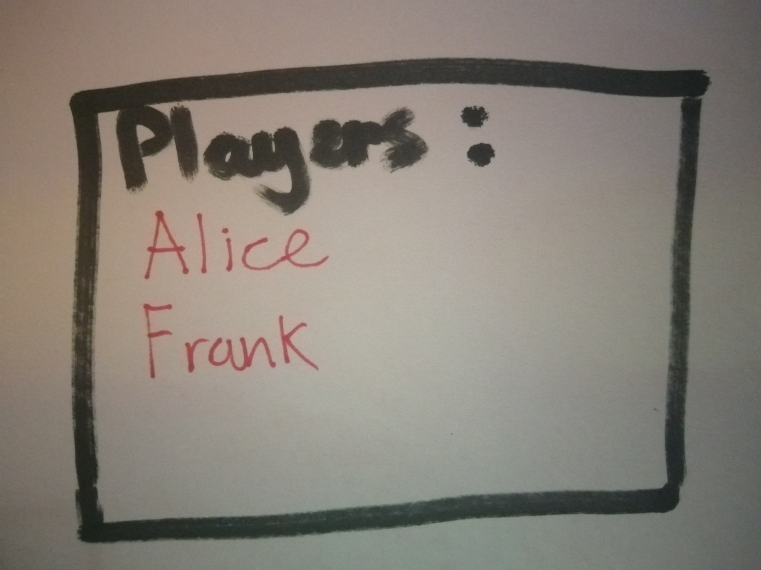Fig 4.7

Laps:

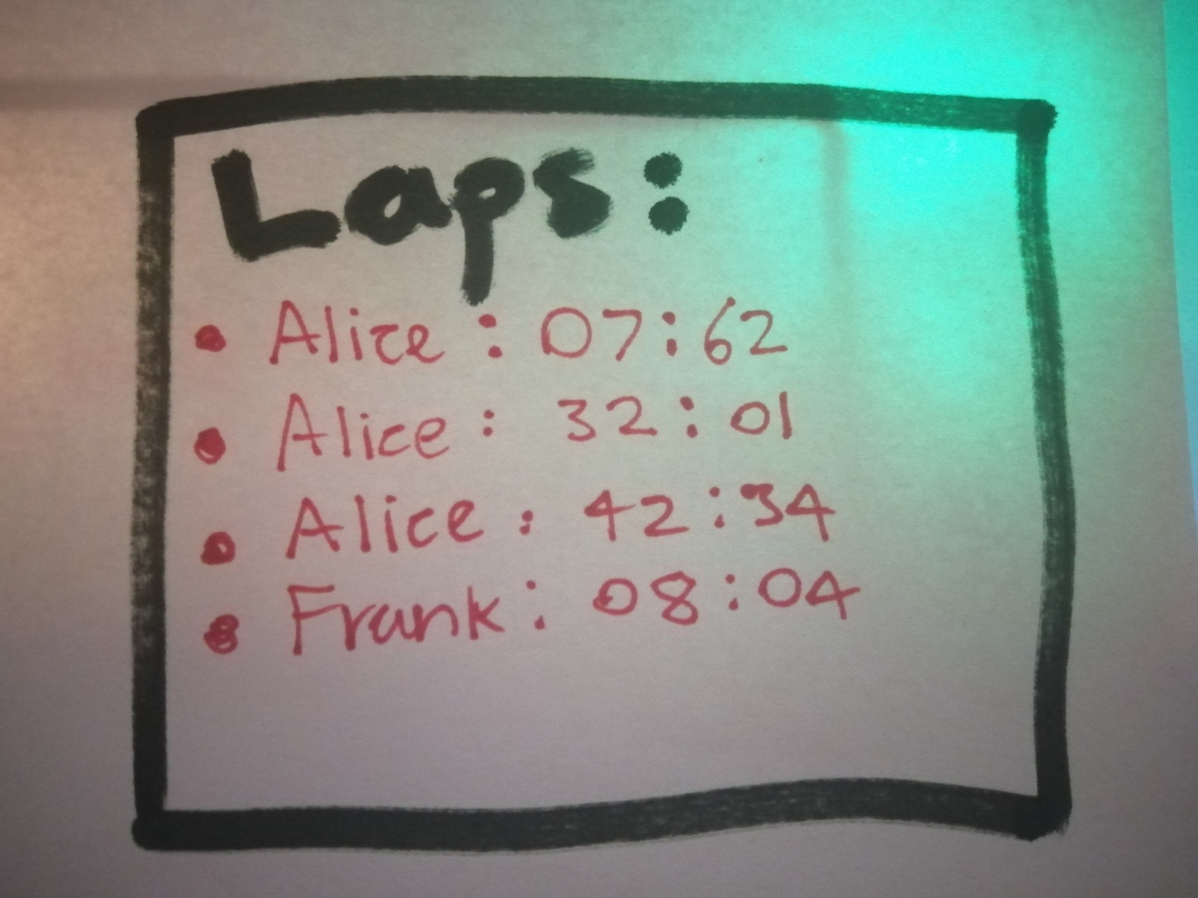Fig 4.8

Throttle:

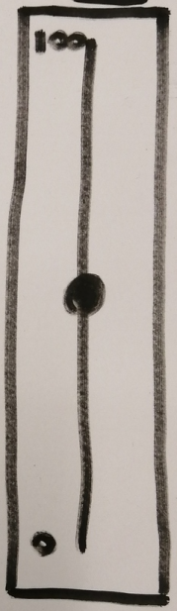Fig 4.9

Switched Throttle:

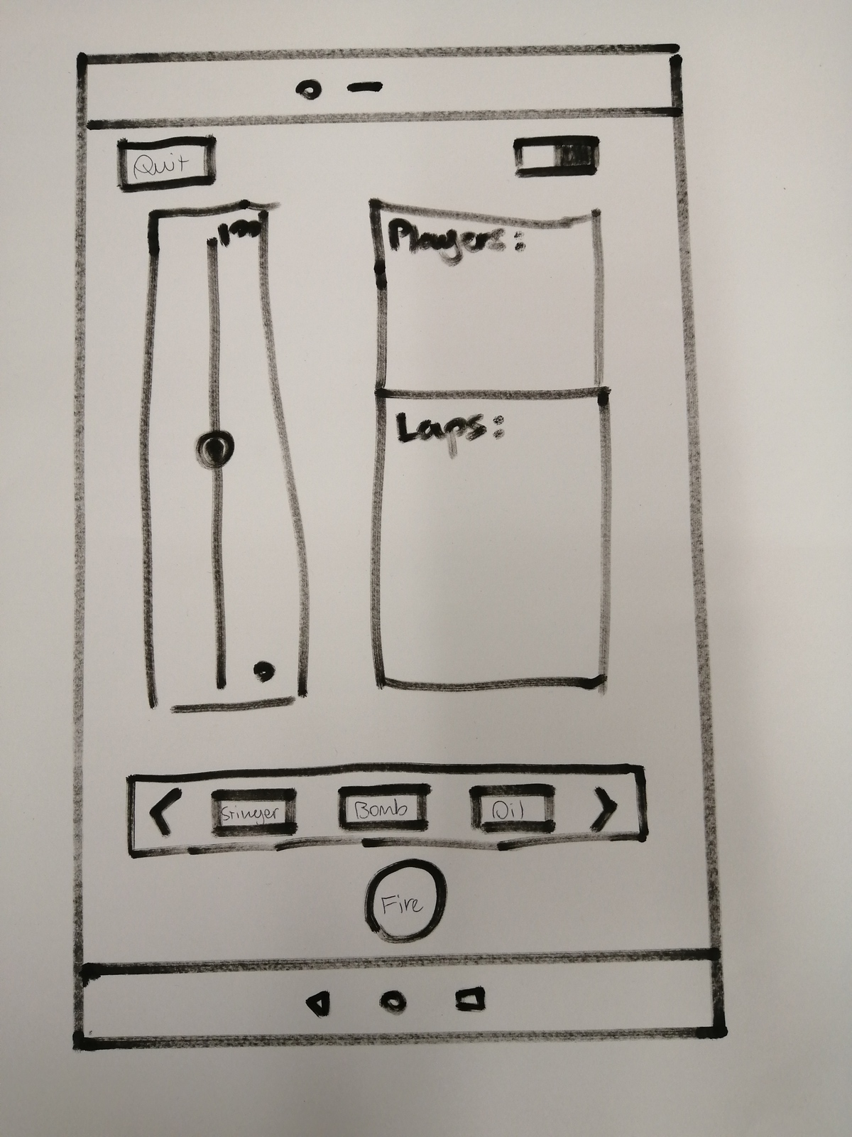Fig 5.0

Weapon Select:

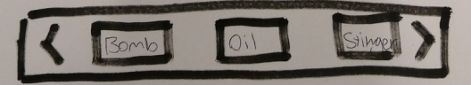Fig 5.1

Fire button:

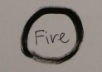Fig 5.2

### Challenge

Whilst in Casual Interactive mode the Users are able to send or accept race challenge requests.

Send Challenge:

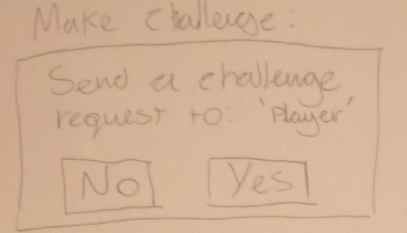Fig 5.3

Accept Challenge:

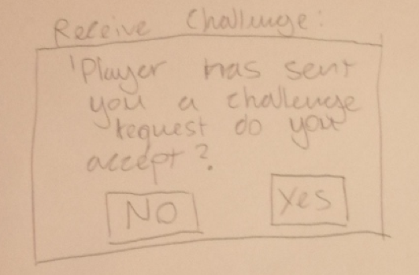

Fig 5.4

Deny Challenge:

Fig 5.5

### Pre Race

After a user has accepted a challenge request both users will enter Pre Race mode

Prepare to enter race mode:

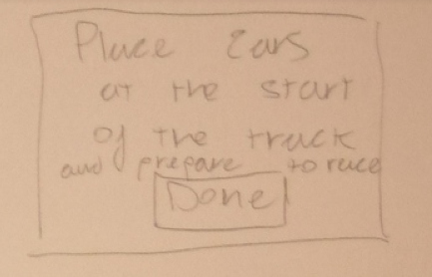.Fig 5.6

### 

### 

### 

### Race

Users are able to compete against each-other in this mode.

UI:

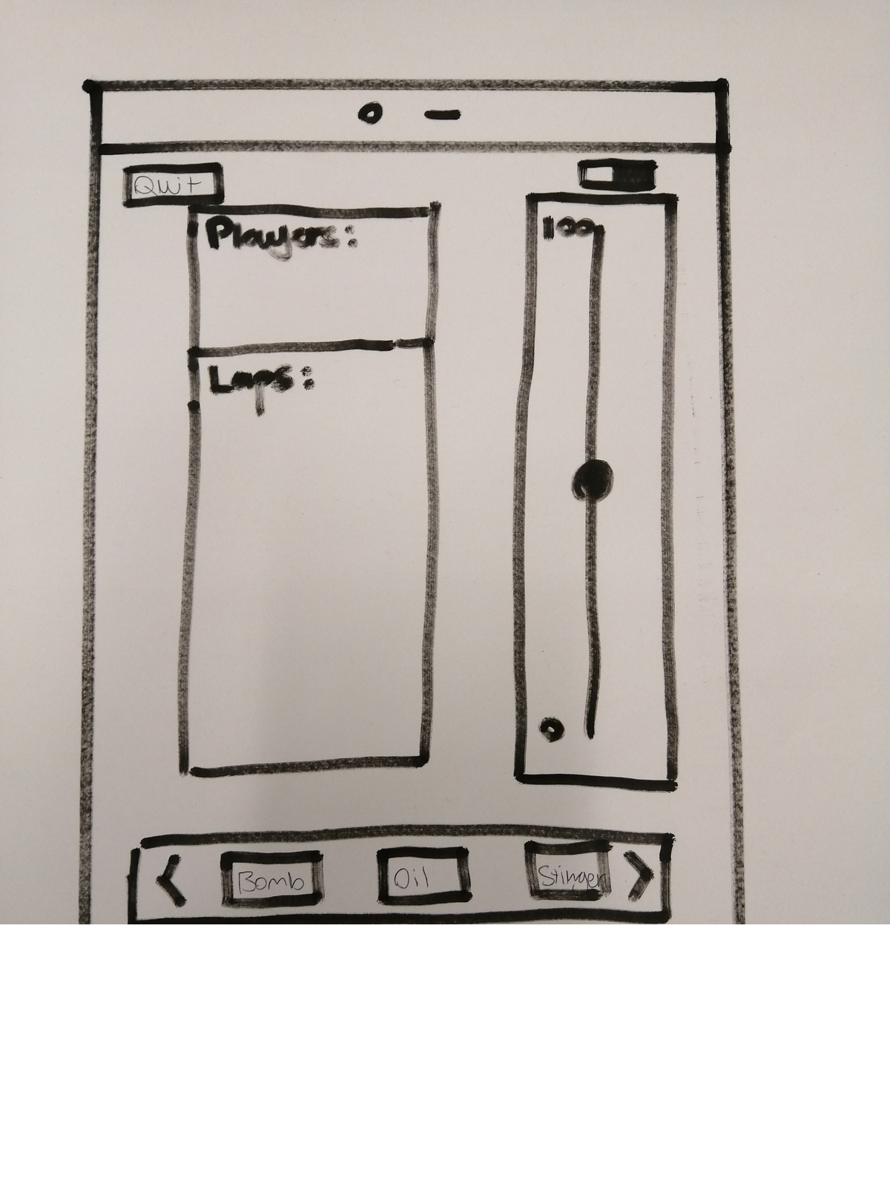Fig 5.7

Winner Declaration:

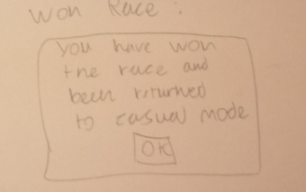Fig 5.8

Loser Declaration:

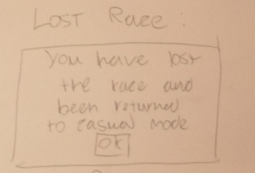Fig 5.9

Quit Race:

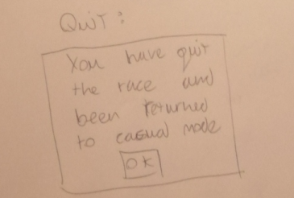Fig 6.0

Opponent quits race:

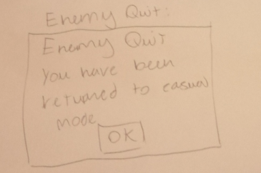Fig 6.1

### Weapons

Whilst any user is in Casual Interactive mode or Race mode they will have different weapons they are able to select and use against other Users.

Usage:

Each user will only be able to fire one weapon every 30 seconds, if the 30 seconds has not elapsed since they last used a weapon the fire button will be disabled.

Stinger:

The stinger stuns the opponent for 10 seconds, reducing their throttle speed to 0.

Oil Slick:

Oil slick will disable the throttle and the speed of the car is oscillated between 0-100 so the car will wobble around the track until the opponent regains control

Smart Bomb:

Smart bombs temporarily set the opponents throttle speed to 100 so they fly off the track.

Reverse Control:

Reverses the opponents throttle speed for 10 seconds, so 0 becomes 100 and 100 becomes 0.

Rick Roll:

Rick roll sets the opponents screen to a video of Rick Astley 10 seconds. <https://www.youtube.com/watch?v=dQw4w9WgXcQ>

### Definitions

Topics:

The broker uses topics to route messages from the publishing client to subscribing clients. Topics are separated by a forward slash (/) that also shows the topic hierarchy.

piUUID:

Used to identify our RaspberryPi on the MQtt servers.

UUID:

A universally unique identifier (UUID) is a 128-bit number used to identify information in computer systems.

The site below is where the pre-existing UUID was made used.

https://www.uuidgenerator.net/

MQTT: Sensors Car Track 1:

This sensor detects a car on track zero

Subscribe to the following topic.

A value will be published when the car passes the sensor and that will let the pi know when a car has completed a lap. Shown in Fig 6.2.

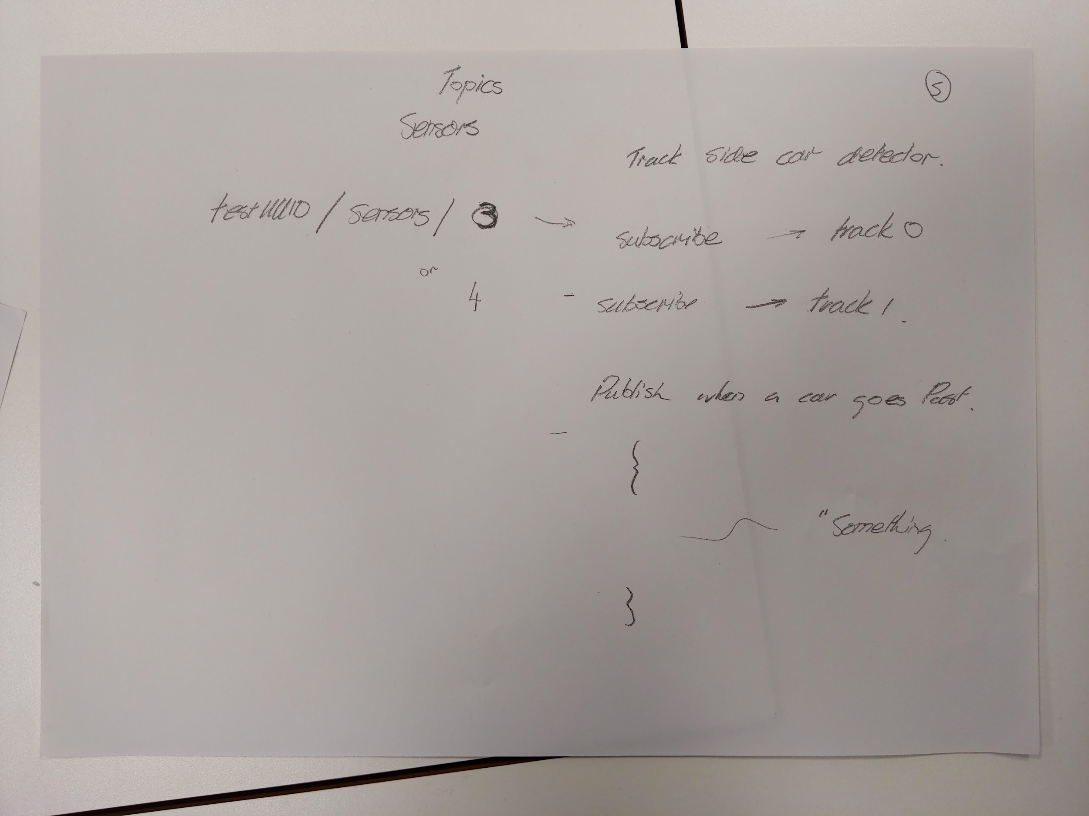Fig 6.2

MQTT: Sensors Car Track 0:

This sensor detects a car on track zero

Subscribe to the following topic.

A value will be published when the car passes the sensor. Shown in Fig 6.3

Fig 6.3

MQTT: Resource List:

Shows all the resources in the mqtt server. Show in Fig 6.4.

I.e Weapons, Throttle...

how to use resources: [https://github.com/aliceliveprojects/pi_scalextric_mqtt/tree/master/mqtt/src/ConFig#resources](https://github.com/aliceliveprojects/pi_scalextric_mqtt/tree/master/mqtt/src/Config#resources)

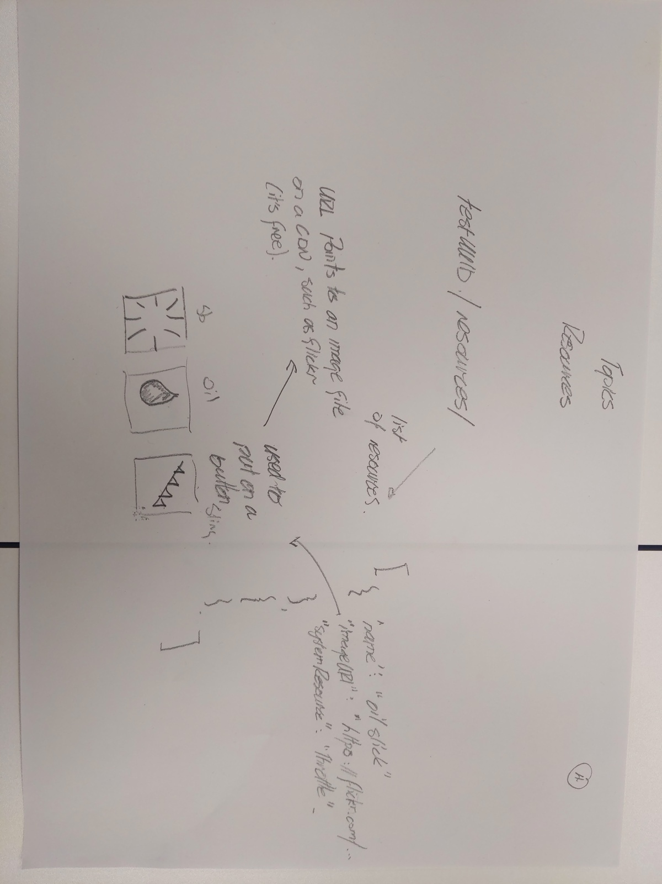Fig 6.4

MQTT: Resources Oil slick track 0:

How to use the Oil slick resource. Shown in Fig 6.5.

For more information refer to the wiki: <https://github.com/liveprojects-julien/pi_scalextric_mqtt#uuidcontrolchannelresourceidstate>

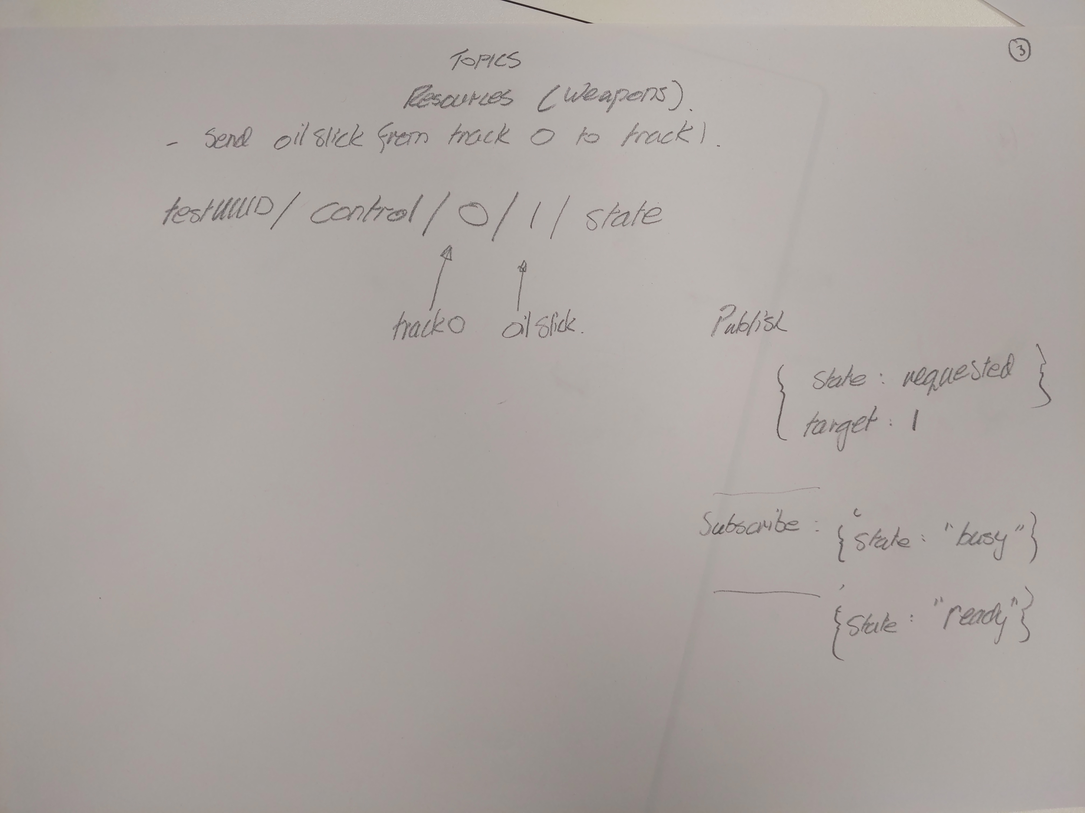Fig 6.5

MQTT: Resources stinger track 0:

How to use the Stinger resource.

For more information refer to the wiki: <https://github.com/liveprojects-julien/pi_scalextric_mqtt#uuidcontrolchannelresourceidstate>

MQTT: Resources smartbomb track 0:

How to use the Smartbomb resource.

For more information refer to the wiki: <https://github.com/liveprojects-julien/pi_scalextric_mqtt#uuidcontrolchannelresourceidstate>

MQTT: Throttle track 0:

Sets the throttle of a specific channel

For more information check the wiki:

<https://github.com/aliceliveprojects/pi_scalextric_mqtt/blob/master/README.md#uuidcontrolchannelthrottle>

# Wireframes

The wireframes are a visual representation of what our app will look like and how it will function, similar to a prototype. We also included some of our User Stories alongside different portions of the wireframe to further explain how the app will work. These were made with Evolus Pencil. These are available to our GitHub pages. <https://liveprojects-julien.github.io/LiveProjectsTemplate/#/page/start>

### Homepage

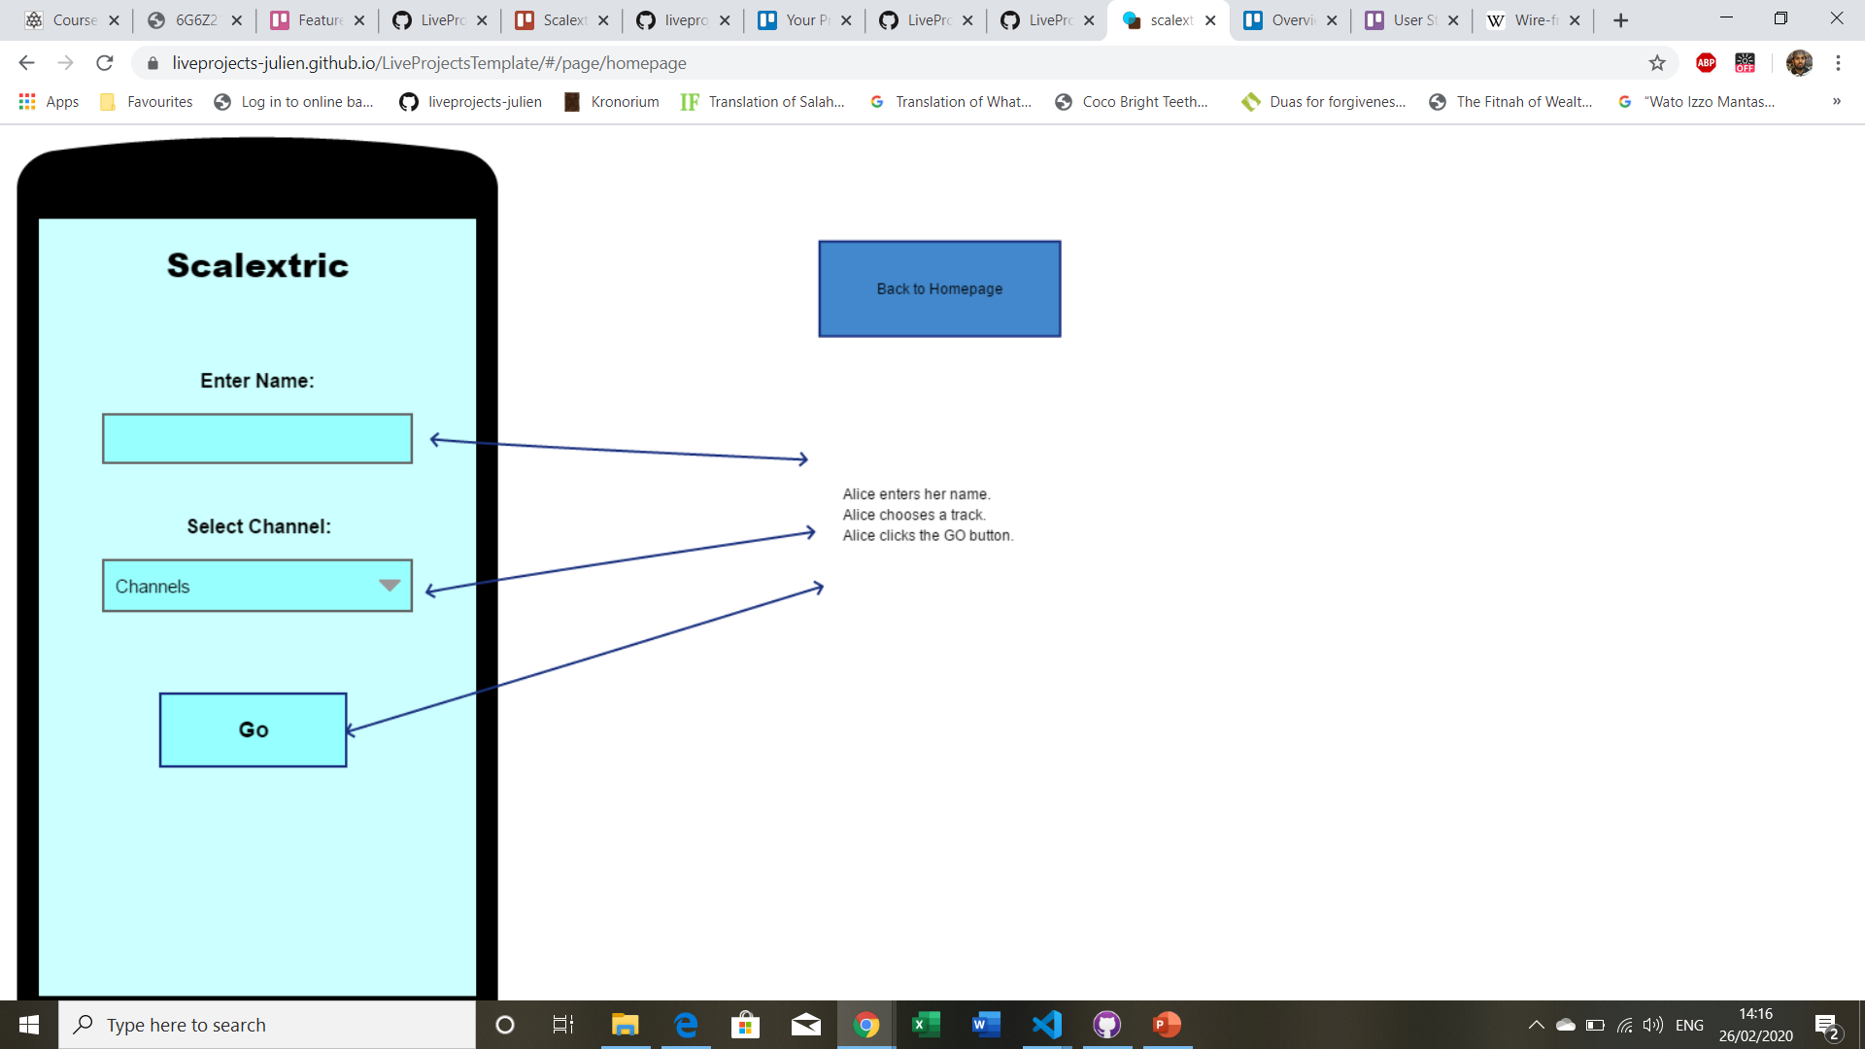Fig 7.0

Alice, the ‘user’ enters her name. Then she selects a track, either 1 or 0. She then clicks go which takes her to the racing mode.

### Casual Alone

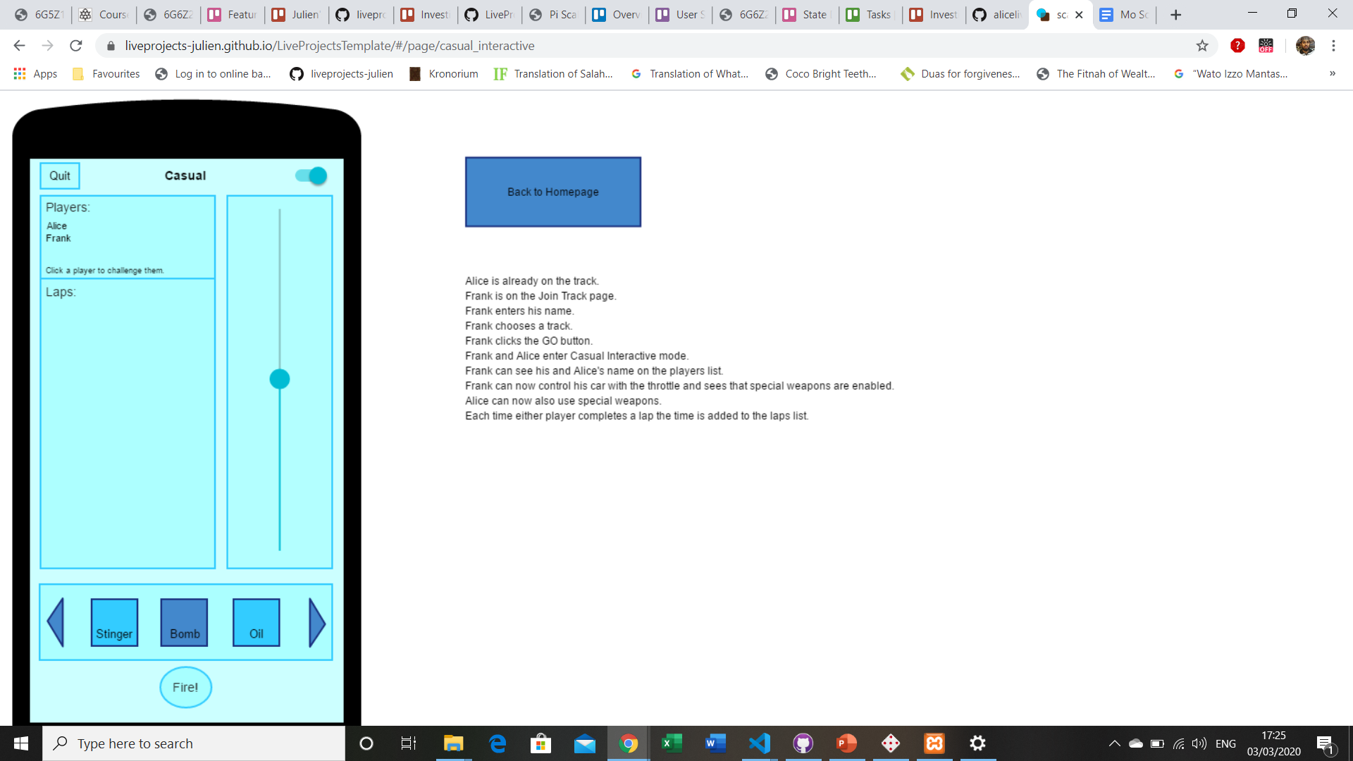Fig 7.1

The image below shows Alice and another use Frank in interactive mode.

### Casual Interactive

There is also a casual interactive mode where Alice and Frank can play against each other. She is now able to control the car using the throttle.

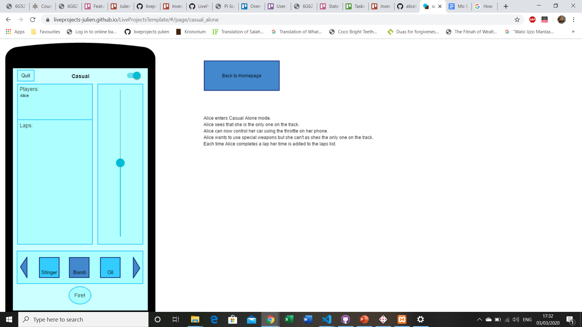Fig 7.2

### Race

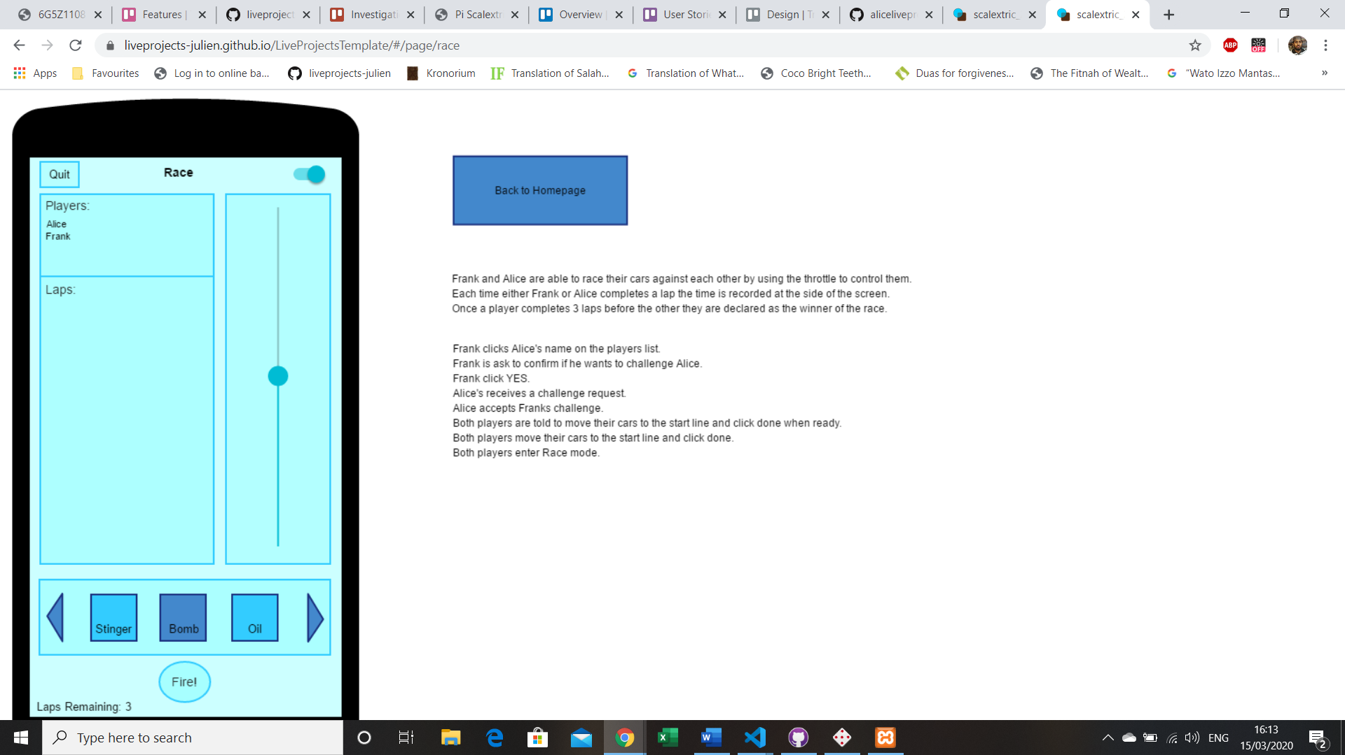Fig 7.3

Frank and Alice are able to race their cars against each other by using the throttle to control them. Each time either Frank or Alice completes a lap the time is recorded at the side of the screen.

### Make Challenge

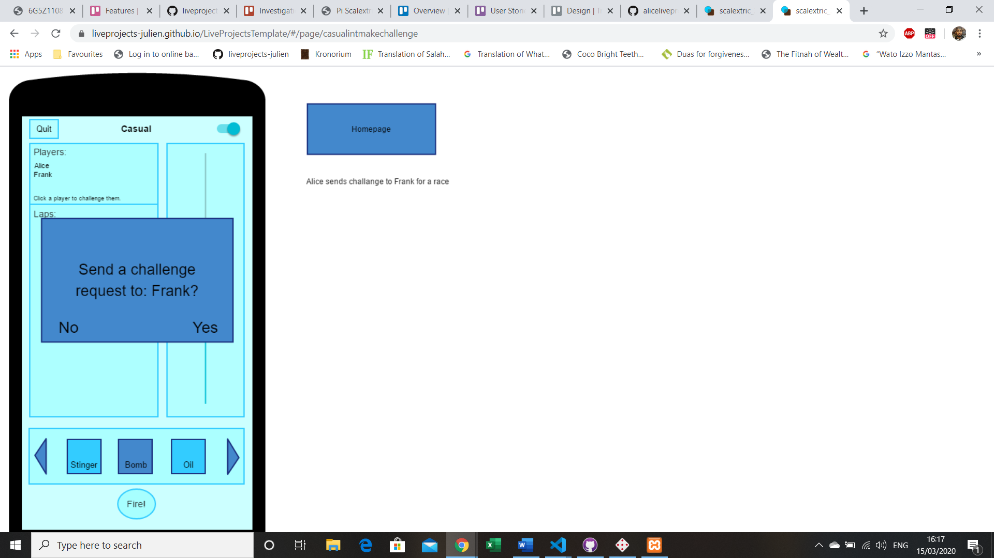Fig 7.4

A pop up of a challenge request is sent to Frank by Alice.

### Accept Challenge

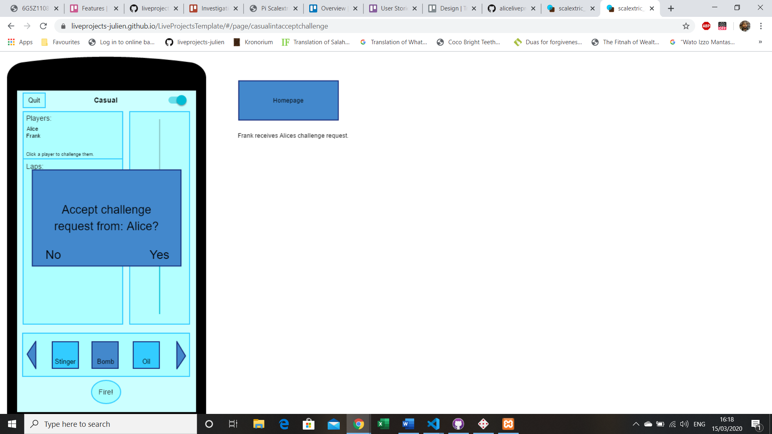Fig 7.5

Frank receives Alice's request for a challenge.

### Pre Race

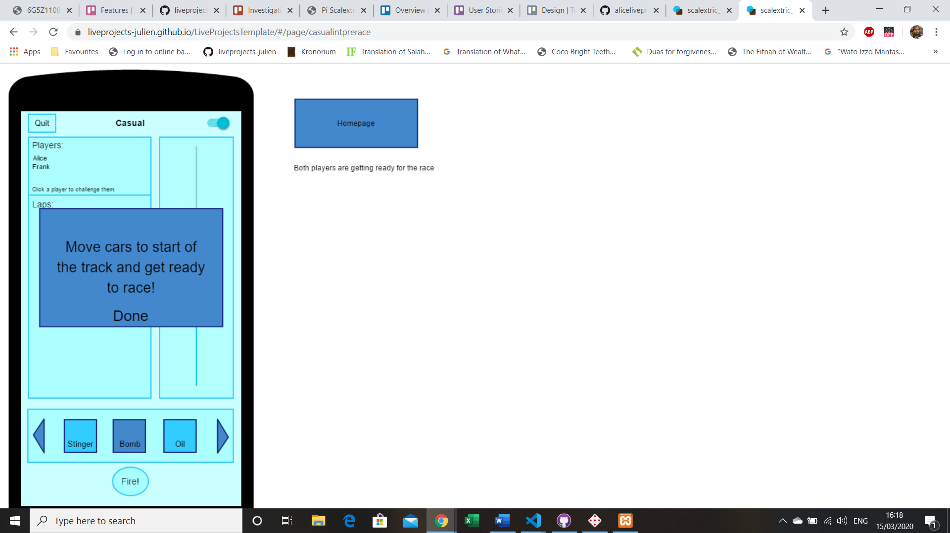Fig 7.6

Both players are getting ready for the race.

### Won Race

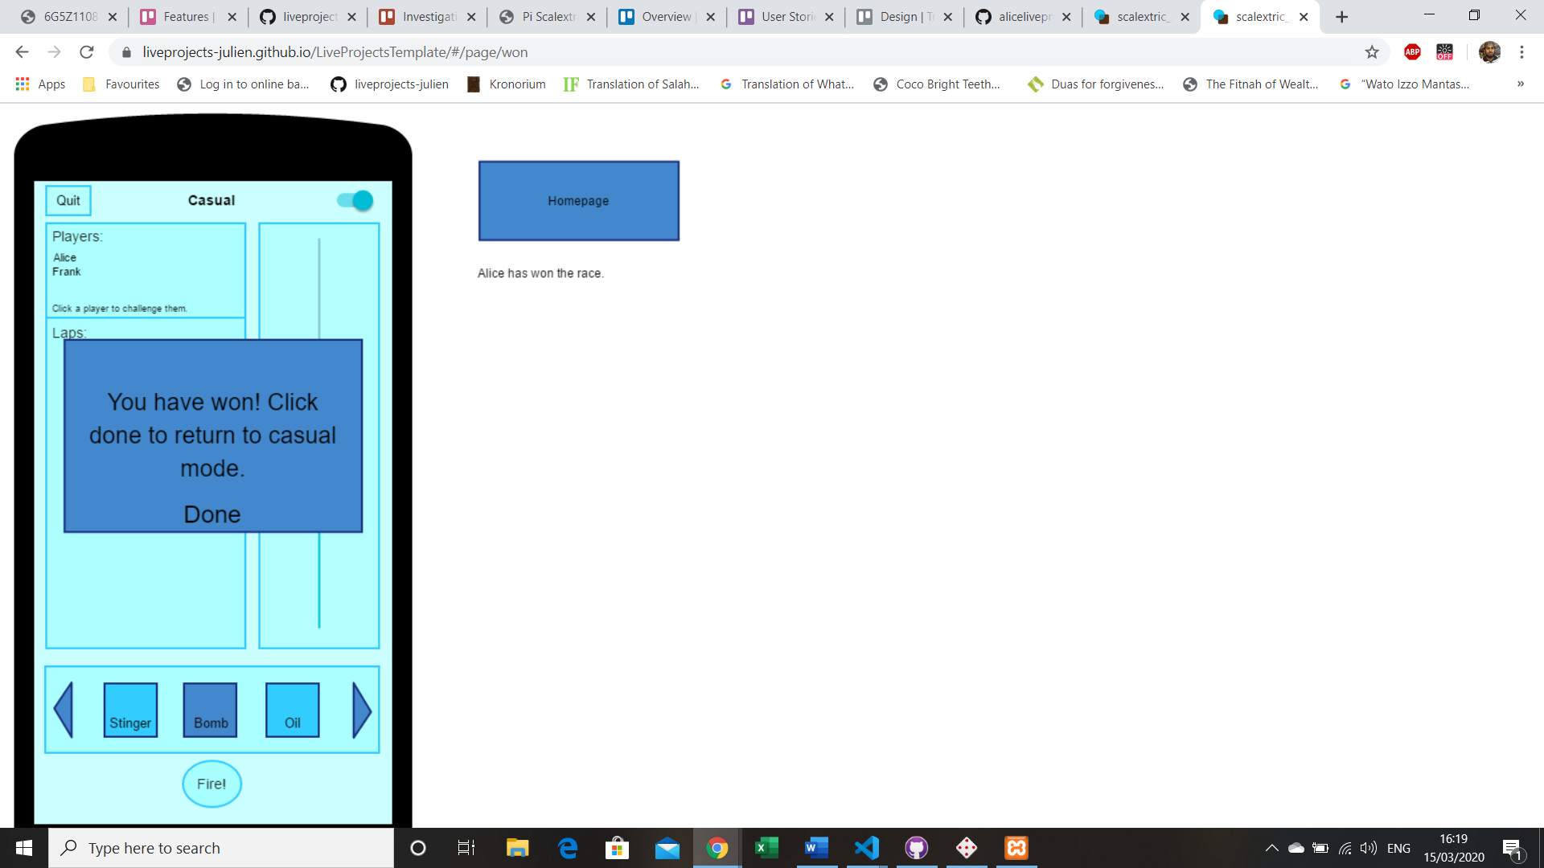Fig 7.7

A notification pops up that Alice has won the race.

### Lost Race

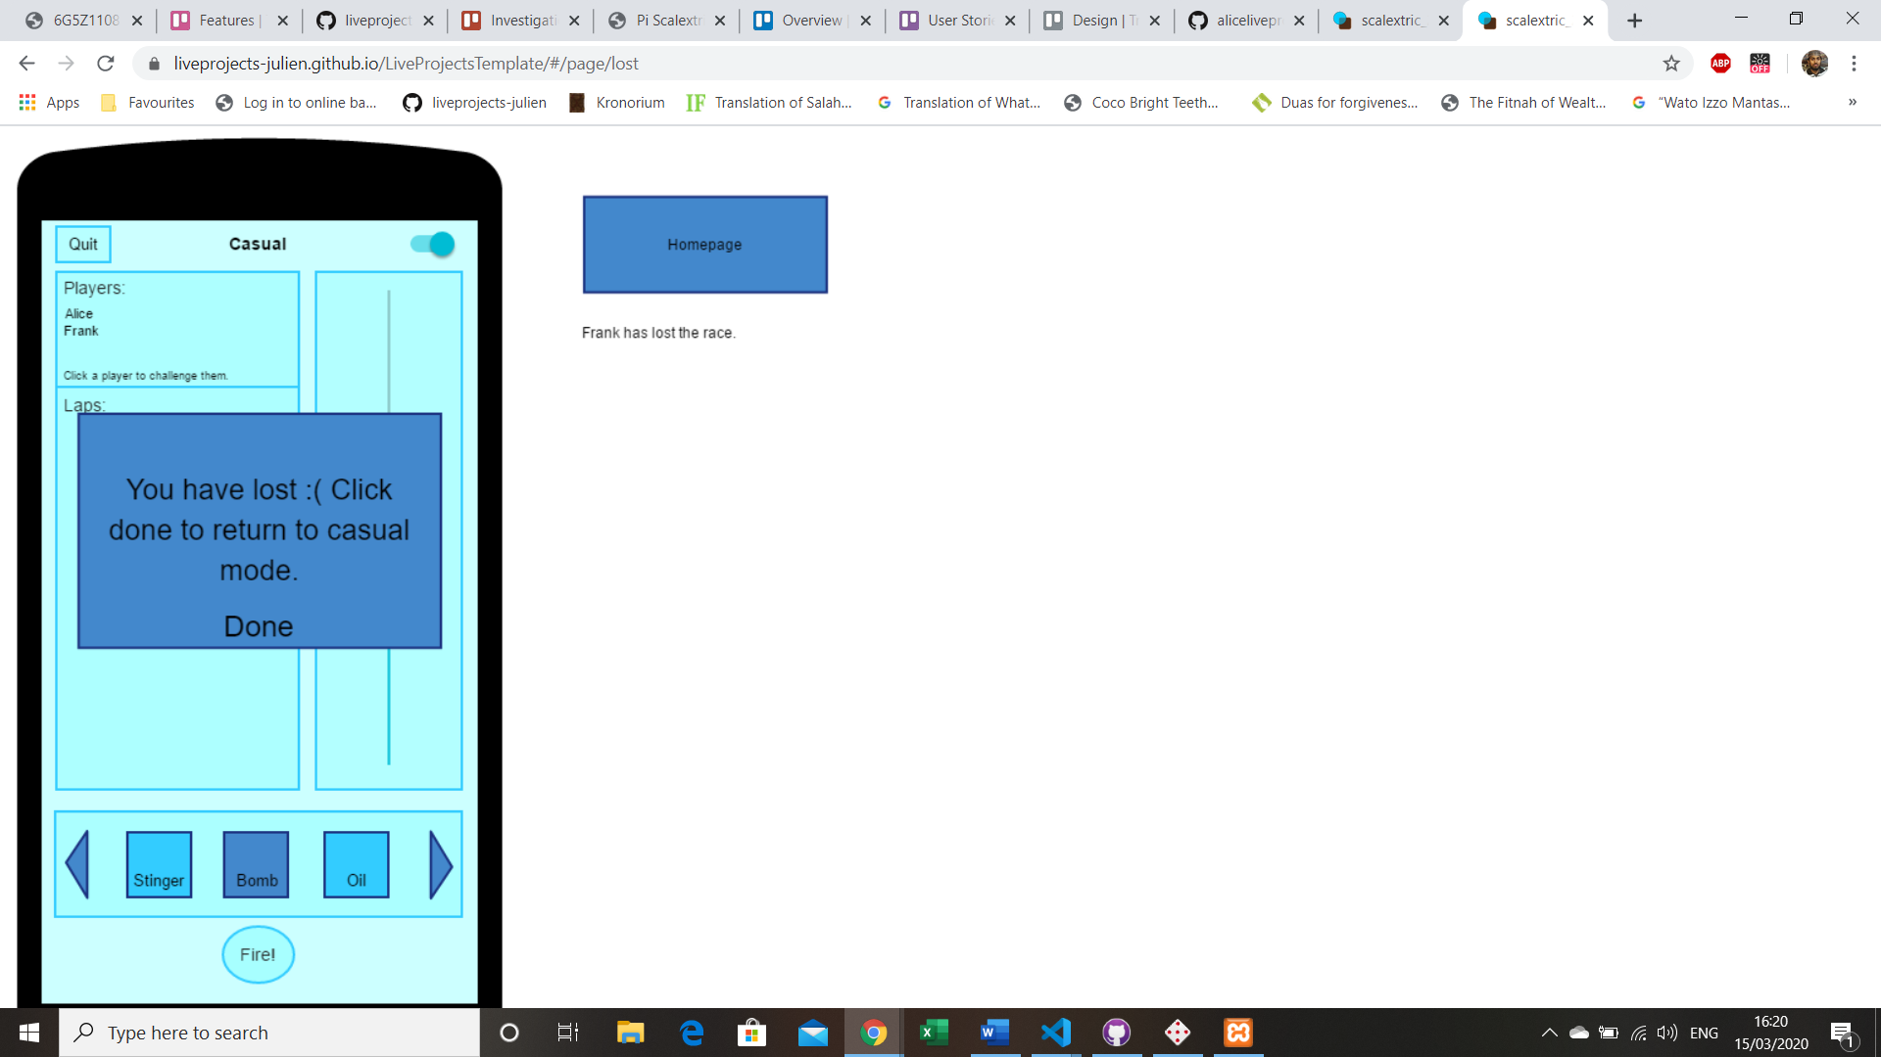Fig 7.8

A notification is sent to Frank that he has lost the race.

# Design

## Web Application

**Homepage**

The homepage users are assigned to this page when when they first load the

[SPWA]. The site is going to be written in AngularJS as it allows web applications to be responsive and have dynamic content. The hosting service that is going to be used is Github Pages

**Features**

**Casual Alone**

This client-side-interaction-angularjs, hosted on Github Pages

The app is intended to be undemanding to use with everything being self intuitive, for any level mobile user.

This is the state default when a user is on the application. Casual Alone allows for the lone user to access the basic components of the app, the race features without weapon usage.

The app should be accessed from a Homepage Link in the form of a QR barcode.

For functional elements: see Wireframes Fig 7.0 to 7.8 or refer to <https://liveprojects-julien.github.io/LiveProjectsTemplate/#/page/start>

**Casual Interactive**

This client-side-interaction-angularjs, hosted on Github Pages

The app is intended to be undemanding to use with everything being self intuitive, for any level mobile user.

This is the state that is only available when a user is on the application with another user at the same time. Casual Interactive allows for the dual users to access the basic components of the app, the race features with weapon usage.

The app should be accessed from a Homepage Link in the form of a QR barcode.

For functional elements: see Wireframes

<https://liveprojects-julien.github.io/LiveProjectsTemplate/#/page/start>

**Challenge**

When there are two players on the track or (Casual Interactive) by a user clicking on a player listed on the player list box section, a pop-up box will appear that will allow them to choose to accept or deny the request.

**Pre Race**

When a player accepts a challenge request a pop up is going to show.

The content is going to be housed by the <md-dialog> directive

for more information check the pop up section of client-side-interaction-angularjs.

The button is going to be a standard angularjs button.

**Race**

"Race" where all the facilities that allow the Scaletrix web app to be a game. This is all the html components that are going to be needed.

***UI***

*Refer to the Fig 7.0 to 7.8 for context*

Pop-up-winner-declaration Fig 5.8

Pop-up-loser-declaration Fig 5.9

Button-quit Fig 6.0

Button-send Fig 5.3

Current-mode-text

Laps-list Fig 4.8

Throttle Fig 4.9

Throttle-switch Fig 5.0

Carousel-or-div-with-tiny-slider-weapon-select Fig 5.1

Button-go Fig 4.4

Button-deny Fig 5.5

Button-accept Fig 5.4

Stinger Fig 5.1

Smart-bomb Fig 5.1

Reverse-control Fig 5.1

Oil-slick Fig 5.1

Rick-roll Fig 5.1

Input-box-enter-name Fig 4.2

Select-box-channel-select Fig 4.3

**Weapons**

This client-side-interaction-angularjs, hosted on Github Pages

This is the state that is in sync with the casual-interactive as it allows users to have access to weapon usage in the race.

For functional elements: see

[Wireframes] <https://liveprojects-julien.github.io/LiveProjectsTemplate/#/page/start>)

**MQTT**

MQTT Broker handles the communication between subscribers and publishers.

The raspberry pi has the sends(publishes) out information to the broker and the subscribers (clients) receive the information

**Components**

**(Not implemented)**

**Input box: Enter Name**

Standard Input box supplied with ng-Model directive to allow for data-binding and state control.

Fig 7.0

**Select Box: Channel select**

HTML select element with AngularJS data-binding.

Fig 4.3

**Pop-up: Winner Declaration**

**(Not implemented)**

The content is going to be housed by the <md-dialog> directive

Fig 5.8

**Pop-up: Loser Declaration**

**(Not implemented)**

The content is going to be housed by the <md-dialog> directive

Fig 5.9

**Pop-up: Send**

**(Not implemented)**

The content is going to be housed by the <md-dialog> directive

Fig 5.9

**Text Box: Current mode text**

**(Not implemented)**

HTML Tag thats holds text

**Text Box: Players List**

**(Not implemented)**

HTML Tag thats holds text

**Text Box: Laps List**

HTML Tag thats holds text

Fig 4.8

**Range Slider: Throttle**

HTML range input with Angularjs data binding

Fig 4.9

**Switch bar: Throttle Switch**

Md switch Angularjs directive

Fig 5.0

**Button: Join**

The button is going to be a standard Angularjs button

Fig 4.4

**Button: Quit**

The button is going to be a standard Angularjs button

Fig 4.6

**Button: Fire**

The button is going to be a standard Angularjs button

Fig 5.2

**Button: Deny**

**(Not implemented)**

The button is going to be a standard Angularjs button

Fig 5.5

**Button: Accept**

**(Not implemented)**

The button is going to be a standard Angularjs button

Fig 5.4

**Button: Stinger**

**(Not implemented)**

The button is going to be a standard Angularjs button

Fig 5.1

**Button: Smart Bomb**

The button is going to be a standard Angularjs button

Fig 5.1

**Button: Oil Slick**

The button is going to be a standard Angularjs button

Fig 5.1

**Button: Reverse Control**

**(Not implemented)**

The button is going to be a standard Angularjs button

Fig 5.1

**Button: Rick Roll**

**(Not implemented)**

The button is going to be a standard Angularjs button

Fig 5.1

**Homepage**

**Homepage State**

Implements the homepage this is a relative structure the stage

***Assets:***

Homepage-view (fig 4.1)

Homepage-controller

**Homepage View**

The SPWA will allow players to enter their name. The name that is entered is going to be the name that other people see on the stats section of the spwa.

Channel select lets players choose the track they start on (1 and 2) and the join button is going to allow a player to the track they specified

***Dependant on:***

Homepage-controller

**Homepage Controller**

The homepage controller will contain all directives, HTML elements needed for the functionality to allow users to connect to the scalextric track

***Assets:***

Input-box-enter-name Fig 4.2

Select-box-channel-select Fig 4.3

Button-go Fig 4.4

**Casual Alone**

**Casual Alone State**

Implements the Casual-alone this is a relative structure to the state.

***Assets:***

Casual-alone-view Fig 7.2

Casual-alone-controller (Combined with casual interactive state)

**Casual Alone View**

The casual alone view will allow a player to control a car on the scalextric.

The view is going to have the ui that allows a person to race on alone on the track.

Refer to wireframes for reference <https://liveprojects-julien.github.io/LiveProjectsTemplate/#/page/start> or Fig 7.0 to 7.8

Dependant on:

Casual-alone-controller

**Casual Alone Controller**

The Casual Alone controller will contain all directives, HTML elements needed for the functionality to allow users to connect to the scalextric track

***Assets:***

- text-box-laps-list Fig 4.8

- text-box-players-list Fig 4.7

- text-box-current-mode-text (Not implemented)

- pop-up-send Fig 5.3

- deny Fig 5.5

- accept Fig 5.6

**Casual Interactive**

**Casual Interactive State**

Implements the casual-interactive this is a relative structure to the state.

when a user is on the state the pre-race starts to move the cars to the same place, the starting line.

***Assets:***

Casual-interactive-controller (Combined with casual interactive state)

Casual-interactive-view (Fig 7.2)

**Casual Interactive View**

The casual Interactive view will allow players to control and race cars on the scalextric.

The view is going to have the ui that allows people to have access to the interactive aspect of the app.

Refer to wireframes for reference

***Dependant on:***

- casual-interactive-controller (Not implemented)

**Casual Interactive Controller**

The Casual interactive controller will contain all directives, HTML elements needed for the functionality to allow users to connect to the scalextric track

***Assets:***

- text-box-laps-list (Fig 4.8)

- text-box-current-mode-text (Not implemented)

- pop-up-loser-declaration (Fig 5.9)

**Race**

**Race State**

Implements the race this is a relative structure to the state.

***Assets:***

- race-view (Fig 7.3)

**Race View**

The race view is where all the race functions are kept.

The view is going to have the ui that allows people to have access to the race aspect of the app.

Refer to wireframes (Page 31) for reference or <https://liveprojects-julien.github.io/LiveProjectsTemplate/#/page/start>

***Dependant on:***

- race-controller

**Race Controller**

The Casual interactive controller will contain all directives, HTML elements needed for the functionality to allow users to connect to the scalextric track

***Assets:***

- range-slider-throttle

- Fig 4.6 (button-quit)

- Fig 5.1 (stinger)

- Fig 5.1 (smart-bomb)

- Fig 5.1 (oil-slick)

- Fig 5.2 (Button Fire)

**MQTT**

**MQTT**

Everything to do with the mqtt have been already established refer to Alice for more help or go to [this site](https://www.eclipse.org/paho/files/jsdoc/Paho.MQTT.Client.html) to learn more about the paho js to talk to the mqtt broker.

**Definitions**

**Controller**

Refer to this [site](<https://docs.angularjs.org/guide/controller>)

**View**

Just a html page that can be with with a controller

**State**

Refer to this [site](<https://ui-router.github.io/ng1/docs/1.0.0-beta.1/classes/state.stateprovider.html>)

# 

# Implementation

Overview

When starting our implementation there was not a lot of time left and also certain members of the group still did not understand how to write in AngularJS so we focused on the core features to make our app usable, getting a working race mode would definitely not be feasible. Here are the main features we completed:

Splashscreen

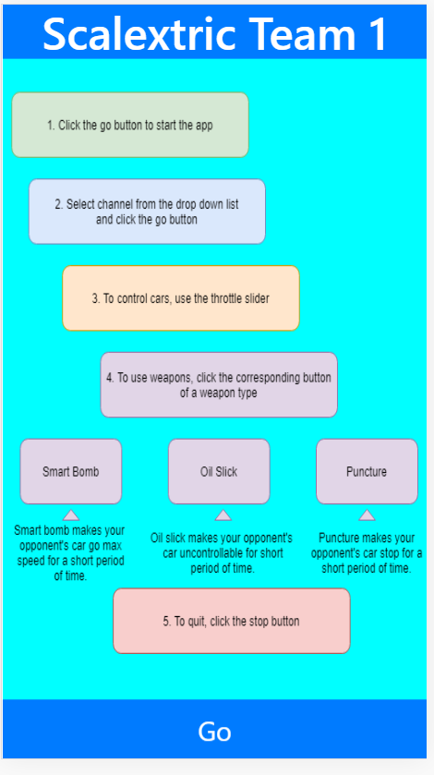Fig 8.0

The splash screen (shown in Fig 8.0) is where all our vital services get initialised and connected together. Essentially the PAHO service talks to the MQTT broker and the MQTT service creates a PAHO client to allow the app to communicate with the broker (Shown in fig 8.1). The message service is a shell over the mqtt service, it acts in such a way that when a subscription is made the place it is made from is also recorded, if this wasn't the case the last subscription request would get overwritten and you would not be able to receive information from multiple states. Although the splash screen and these services were not in our requirements it was fundamental to include these features otherwise our app would not function properly.

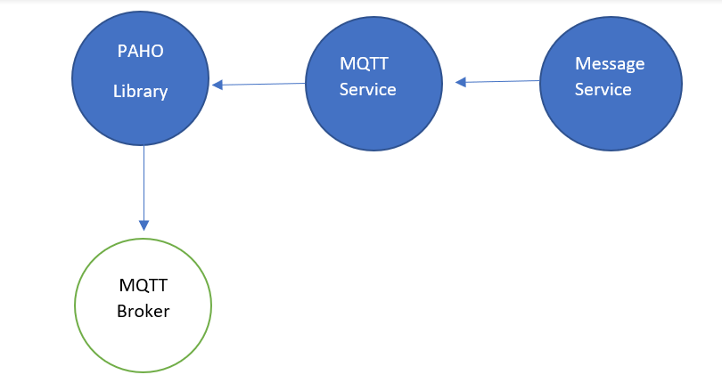Fig 8.1

Message Service

As explained above the Message Service is absolutely crucial as when the app subscribes to a topic the place where it subscribes from is recorded along with the topic that has been subscribed too, this is so the subscription cannot be overwritten. This service also contains almost the same functions as the MQTT service that act as a shell for that service too.

MQTT Service

This is where the PAHO client is created, this allows us to talk to the MQTT broker. This service contains our publish and subscribe functions which and also other functions such as on message arrived which allows us to choose a topic we want subscribe too and receive all the information published to said topic.

Error Handling

The error handling that we implemented detects when the user has been disconnected and attempts to reconnect them 10 times, if they can't reconnect they are sent back to the splashscreen, if they are successfully reconnected then they can continue using the app as normal. The error handling is done within the MQTT service.

Car Control

Originally the throttle in our car control state used the MQTT service to communicate with the broker but now we have the message service it goes through that instead. Each time the range slider (throttle shown in Fig 8.1) is changed this value is then published to the MQTT broker (This meets our Core requirement: ‘Controls: General’). The Quit button (shown in Fig 8.1) disconnects you and sends you back to the splash screen (This meets our Core requirement: ‘Quit: General’). Also we have implemented a lap timer, this works by subscribing to the sensor topic on our MQTT broker and recording the time via a timer each time the car passes over the sensor (This meets our Core requirements: ‘Laps’ and ‘Lap Times’’). (Refer to user story in fig 7.1 and 7.2)

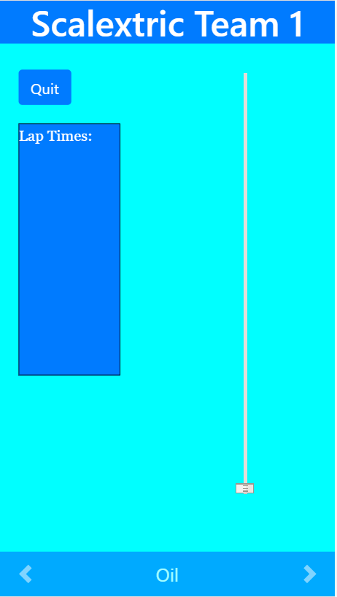Fig 8.2

Alone Service

This service uses a unique UUID for each player connected and publishes that to a topic on our mqtt broker depending on which channel the player is connected too, this way we can see if UUIDs that are not our own on specific channel and determine if the track is in use or not. This service allows us to meet our Core requirements: On-boarding: Two Players and also all of our Weapons requirements. Without this service our weapons would not function properly as we would not know when there is another player on the track. This service acts as a base for a lot of our added features and will also serve as a base for lots of features that could be implemented in the future.

Weapons

The player is only able to use a weapon once every 20 seconds, also if they are alone on the track the weapons are disabled. Weapons work by requesting resource ID from the Pi then sending a request back to the Pi asking for a specific weapon to be activated. This has allowed us to meet all our Core: Weapons requirements other than Reverse Control and Rick Roll.

Lap timer

Each time the user passes a sensor the amount of time they took (timed by the $timeout service in angular JS) to go round the track is appended to a list box. This has allowed to meet our Core: Laps and Lap times requirements

Homepage

In this state we have a selection box allowing the user to select which channel they would like to join, if the user selects a channel that is already occupied they will get a notification saying they cannot join it, this is done using our Alone Service. This means we have met our Core: On-Boarding Single Player and On-Boarding Two Players requirements. (Refer to user story in fig 7.0)

GUI

We used bootstrap libraries and CSS to style our HTML elements.

All of our buttons used bootstrap styling (shown in Fig 8.1, 8.2 and 8.3, we also used a bootstrap carousel for the weapons selector.

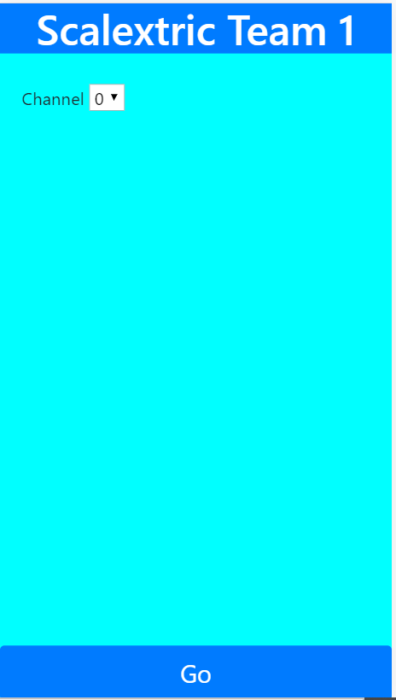Fig 8.3

We have also met our Core: casual requirements as any user is able to race around the track casually for as long as they wish.

# User guide

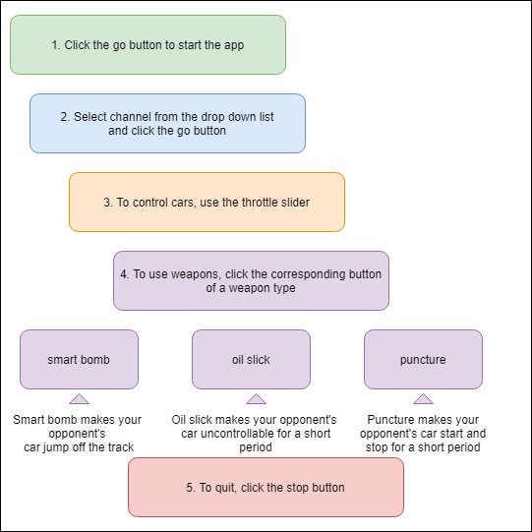Fig 9.0

We made an instructional image (shown in Fig 9.0) on how to use our app.

We start the app either scan this QR code (shown in Fig 9.1) from your device:

Fig 9.1

Or follow this link:

<https://liveprojects-julien.github.io/pi_scalextric_t1_spwa/docs/index.html#!/index?brokerPort=443&brokerHost=thedigitallabsmqtt.herokuapp.com&uuid=testUUID&ssl=true>

Our Github for the project can be found here:

<https://github.com/liveprojects-julien/pi_scalextric_t1_spwa>

# Handover report

If people want to carry on our project, they would need to understand the technologies involved, here is a list of them and the main concepts:

**Software**

Angularjs and its services

* Animate

AngularJS provides animation hooks for common directives such as ng-Repeat and ngView, as well as custom directives via the $animate service.

* Sanitize

The input is sanitized by parsing the HTML into tokens. All safe tokens (from a whitelist) are then serialized back to a properly escaped HTML string. This means that no unsafe input can make it into the returned string

* Ui-router

UI-Router provides state based routing. Each feature of an application is defined as a state. One state is active at any time, and UI-Router manages the transitions between the states.

* Uuid

Provides Uuids. UUIDs are identifiers that are unique.

Paho mqtt js

The Paho JavaScript is an MQTT browser-based client library written in Javascript that uses WebSockets to connect to an MQTT Broker.

Bootstrap

*****We used the bootstrap for the carousel feature that will house the weapons we have currently implemented

**Services**

Mqtt broker

MQTT Broker handles the communication between subscribers and publishers.

The raspberry pi has the sends(publishes) out information to the broker and the subscribers (clients) receive the information.

Github

The web application is hosted on github pages. Pages is a service that github provides that allows you to have a static site that takes HTML, CSS, and JavaScript files straight from a repository on GitHub.

Pencil

Evolus Pencil is a prototyping and wireframing tool, which is ridiculously easy to use, and which exports your wireframes to html.

## Features

**Casual alone**

This is the state default when a user is on the application. Casual Alone allows for the lone user to access the basic components of the app, the race features without weapon usage.

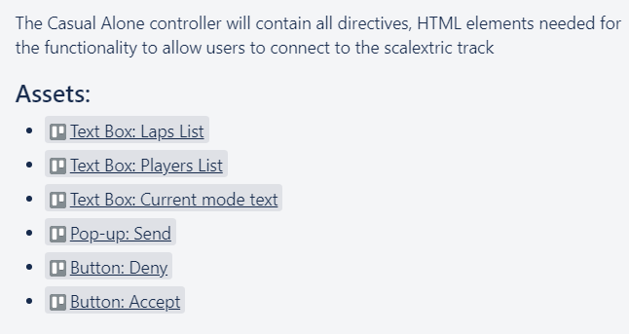Fig 10.0

**Not implemented**

* Players list
* Current mode text
* Send
* Accept
* Deny

**Casual Interactive**

This is the state that is only available when a user is on the application with another user at the same time. Casual Interactive allows for the dual users to access the basic components of the app, the race features with weapon usage.

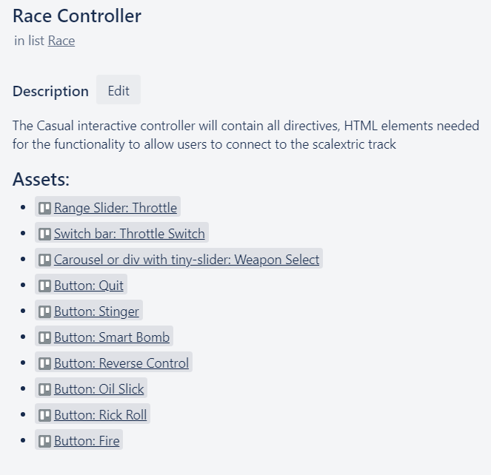Fig 10.1

**Laps List**

Shows the lap times of the scalextric cars when they pass the infrared sensor. This feature is slightly handicaped by the hardware as the sensor isn't reliable.

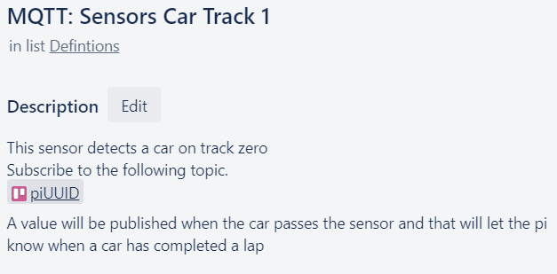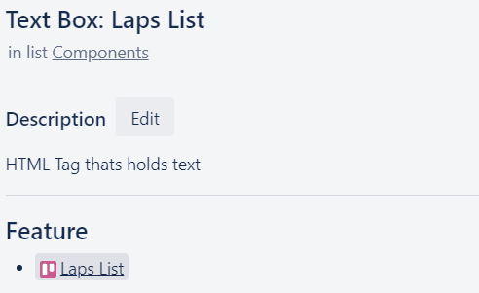Fig 10.2 and Fig 10.3

**Weapons**

Weapons are in sync with the casual-interactive state as it allows users to have access to weapon usage in the race.

Weapons:

* Stinger (Not implemented)
* Oil Slick
* Smart Bomb
* Reverse Control (Not implemented)
* Rick Roll

How the app works

**MQ Telemetry Transport** uses a publish/ subscribe is a style of messaging application in which the providers of information (publishers) have no direct link to a specific consumer of the information (subscribers). The interactions between the publishers and subscribers are controlled by brokers. We use this lightweight messaging protocol to control the communications within our app using an online broker from the web to handle our publications and subscriptions. We have changed our broker supplier it was (test.mosquitto.org) but it's currently (thedigitallabsmqtt.herokuapp.com).

We have a Pi that connects to the mqtt broker and it publishes the resources (throttle value, sensors and weapons) and it subscribes to the publications that return values like the current throttle value, resource being used and sensor.

On the client side we have a javascript app that communicates with the online broker using the Paho.MQTT. library to communicate with the broker to control the scalextric cars using websockets to communicate with the broker. We use the javascript library to publish and subscribe to stuff that is relevant to controlling the scalextric cars.

To have a look on how we are doing that, you can have a look at our source code on Github.

[<https://github.com/orgs/liveprojects-julien/teams/mobile-scalextric-team-1/repositories>]

# Conclusion

Overall, our project managed to be accomplished with multiple features working. The app involves the use of throttle, weapons and it was styled to look almost identical to our wireframe to keep it accurate. Our Tech Lead managed to implement almost all of our Core features from ‘Discussions’ as we discussed as a group earlier from the design phase that we could implement this, as it would not take too long to accomplish.

Although we have met all of our ‘InScope Core’ requirements other than Player ID, there have been one or two features that were difficult to implement within the timeframe. One was implementing extra weapons since they would take extra time for the Tech lead to figure out how to code it within the time limit. So from this point we could have placed the additional weapons under our ‘InScope-Sacrificial’ as it is not an option to completely throw them out of scope.

However, the project was complete with a functional single page web application with functional controls and weapons, so two players can race against each other and have fun using weapons on each other and they can record their own lap times against each other to make it competitive. Therefore, our main objective was complete.